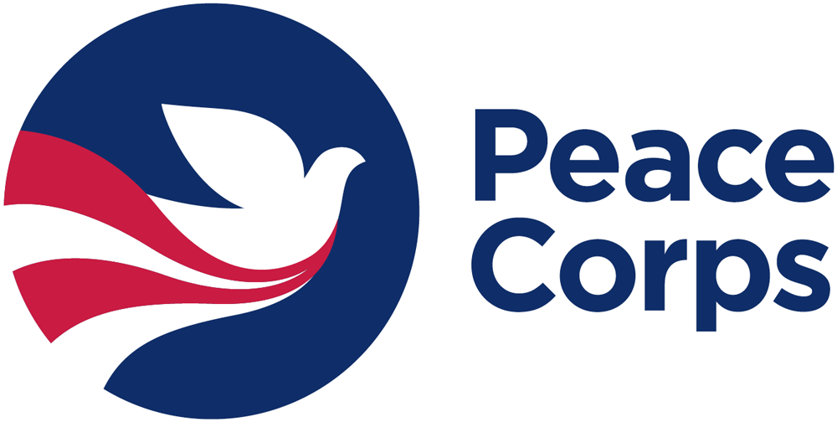
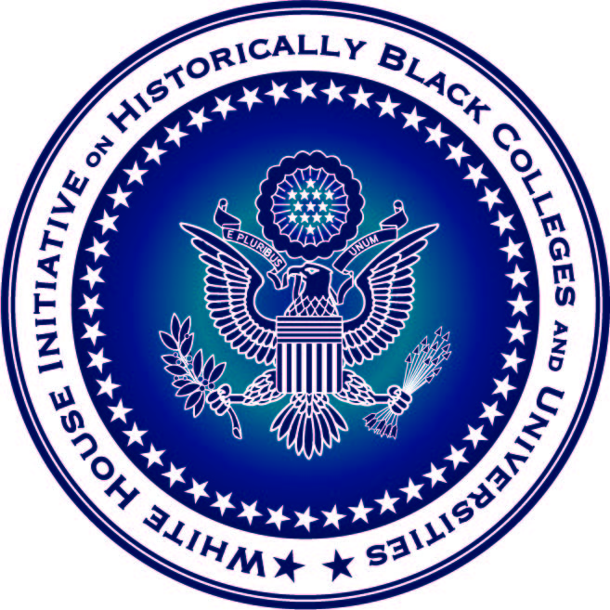
International Opportunities Federal Panel Series
Interest Form

Point of Contact Information
Name |  | Title
Phone # |  | Email
Relation to Institution
Institution (College/University) Information
Institution Name
Institution Address
HBCU? (Yes or No)

Availability
Please select 3 dates or date ranges during each semester that your institution would be available to host the Federal Panel.
Spring 2018 Semester Available Dates

Fall 2018 Semester Available Dates

Federal Panel Audience
Please select all that apply:
____ Students _____ Faculty ____ Staff

Participating Federal Agencies
Indicate what Federal Agencies you would like to have represented on the International Opportunities Federal Panel at your institution. We will do our best to accommodate your request.

1. ____________________________________
2. ____________________________________

3. ____________________________________
4. ____________________________________

