How Historically Black Colleges and Universities Can Seek Federal Funding from the National Endowment for the Humanities

NEH staff contributors: Patricia Brooks, Mary Downs, Deborah Hurtt, Brandon Johnson, Mary Macklem, and Mackenzie Shutler
WHIHBCU staff contributors: Ivory A. Toldson and Tammi Ferguson
Prelude

This series is designed to expand federal support of HBCU research, programs, and outreach through competitive grants and contracts. “Humanities” is the study and interpretation of languages, linguistics, literature, philosophy, archaeology, comparative religion, ethics, history, criticism, and theory of the arts. In this discipline the body of knowledge is applied to the human environment with particular attention to reflecting our basic heritage, traditions and history for its relevance to the current conditions of national life. The National Endowment for the Humanities (NEH), an independent federal agency created in 1965, is the largest funder of the humanities in the United States. The agency offers awards through seven grant-making divisions and offices.

Highlights
- To date, NEH has awarded $5 billion in grants to build the nation’s cultural capital—at museums, libraries, colleges and universities, archives, and historical societies—and advance our understanding and appreciation of history, literature, philosophy, and language.
- There are seven divisions and offices that award grants and support for NEH and NEH offers more than 30 grant programs in areas such as research, preservation, education, and public programming.
- Since 1966, the National Endowment for the Humanities has awarded more than 845 grants worth more than $35.13 million to HBCUs.
- Two NEH grant programs are designed for faculty and staff at HBCUs: Humanities Initiatives at HBCUs and the Awards for Faculty at HBCUs programs. Two additional programs have a special encouragement for applications from HBCUs: Preservation Assistance Grants and Humanities Access Grants.

Introduction and Overview

Celebrating its 50th anniversary as an independent federal agency in 2015-16, the National Endowment for the Humanities (NEH) brings the best in humanities research, public programs, education, and preservation projects to the American people. To date, NEH has awarded $5 billion in grants to build the nation’s cultural capital—at museums, libraries, colleges and universities, archives, and historical societies—and advance our understanding and appreciation of history, literature, philosophy, and language.

NEH offers more than 30 grant programs in areas such as research, preservation, education, and public programming. NEH grants typically support cultural institutions such as museums, archives, libraries, colleges, universities, public television and radio stations, and individual scholars and faculty members.

There are seven divisions and offices that award grants and support at NEH. These divisions and offices are:

- The Division of Preservation and Access: awards grants to preserve, maintain, and improve access to primary sources in the humanities, in both digital and analog form
- The Division of Public Programs: supports projects that bring the humanities to large audiences through libraries and museums, television and radio, historic sites, and digital media
- The Division of Research: makes awards to support original scholarship in all areas of the humanities, funding individuals as well as teams of researchers and institutions
- The Division of Education: works to support and strengthen teaching of the humanities
- The Office of Federal/State Partnership: collaborates with 56 state and territory humanities councils to strengthen local programs
- The Office of Challenge Grants: administers grants intended to support centers and endowments through fundraising by humanities institutions to further long-term stability
- The Office of Digital Humanities: advises on use of technology in the humanities

Since 1966, the National Endowment for the Humanities has awarded more than 845 grants worth more than $35.13 million to HBCUs. Some of the recent awards to HBCUs include:

- $100,000 to Lincoln University of Pennsylvania for a two-year NEH grant to research and develop teaching modules on Lincoln University’s diasporic heritage.
- $96,297 to Albany State University for a two-year NEH grant to provide a humanities bridge program over two summers for high school students on the history, literature, art, and music of the civil rights movement.
- $25,200 to Professor Bertis English for an NEH individual research grant to research and write about racial cooperation in Reconstruction-era Perry County, Alabama.
- $33,600 to Professor Susmita Roye for an NEH individual research grant to examine women writers and the portrayal of women in British-Indian fiction and write a book on the topic.
- $6,000 and $3,640 in two grants to Southern University at Shreveport for Preservation Assistance Grants to help preserve archival collections (historical documents, photographs, newspapers, art and artifacts) documenting the lives of African Americans in Northwest Louisiana.

Liaison between NEH and the White House Initiative on HBCUs

Eva Caldera is the Assistant Chairman for Partnership and Strategic Initiatives in the Office of the Chairman and serves as the NEH liaison to the White House Initiative on HBCUs. Frank Shaw, Senior Program Analyst in the NEH Office of Planning and Budget, assists Eva Caldera as the White House Initiative on HBCUs Representative.

With NEH since 2009, Ms. Caldera has worked with partners ranging from US foundations to foreign governments to universities and libraries across the country. She is leading the special initiative launched by NEH Chairman William Adams, The Common Good: The Humanities in the Public Square. Designed to demonstrate the critical role humanities scholarship can play in our public life, that effort encompasses grant programs across the Endowment.

Eva Caldera- (202) 606-8634 | ecaldera@neh.gov
Frank Shaw- (202) 606-8625 | fshaw@neh.gov

NEH Grant Programs Specific to HBCUS

Two NEH grant programs are designed for faculty and staff at HBCUs: Humanities Initiatives at HBCUs and the Awards for Faculty at HBCUs programs. Two additional programs have a special encouragement for applications from HBCUs: Preservation Assistance Grants and Humanities Access Grants.

NEH Humanities Initiatives at Historically Black Colleges and Universities Grants

This program is intended to strengthen the teaching and study of the humanities, in subjects such as history, philosophy, literature, religion, the interpretation of the arts, and others.

- These grants may be used to enhance existing humanities programs, resources, or courses, or to develop new ones.
- Applicants are encouraged to draw on the knowledge of outside scholars who would contribute expertise and fresh insights to the project.
- Each project must be organized around a core topic or set of themes.

NEH Humanities Initiatives may create opportunities for faculty members to study together, in order to improve their capacity to teach the humanities; support new humanities programs (which may include but are not limited to new humanities minors, first-year seminars, and capstone courses), and enhance existing ones; support humanities contributions to professional training (in such fields as business, law, economics, technology, and nursing and medicine); develop bridge programs for at-risk and nontraditional students; help institutions take advantage of humanities resources, especially in the digital humanities; and support collaborative projects in the humanities between the applicant institution and another institution, such as a college or university, a school or school system, a museum or library, or a historical or cultural society.

In addition to the Humanities Initiatives program, members of the HBCU community are encouraged to apply to other grant programs in the NEH Division of Education Programs, all of which are intended to strengthen the teaching and study of the humanities, in subjects such as history, philosophy, literature, religion, and the interpretation of the arts. See Humanities Connections, Humanities Initiatives at Community Colleges, Summer Seminars and Institutes, and Landmarks of American History and Culture.

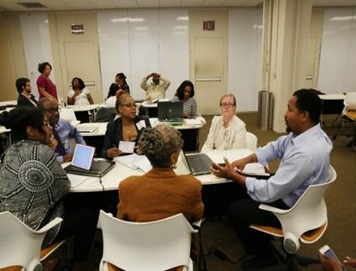

Faculty at Albany State University were awarded an NEH Humanities Initiatives Grant (AB-50103-12) to develop a summer bridge program for high school students (“Albany, Georgia: Gateway to the National Civil Rights Struggle”)

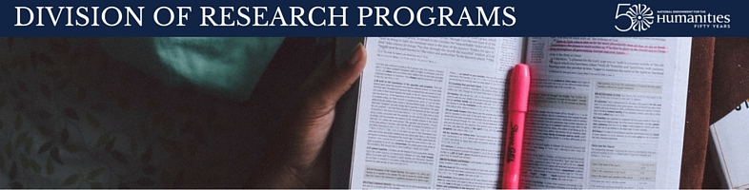

Awards for Faculty at Historically Black Colleges and Universities

This program supports individual faculty or staff members at HBCUs pursuing research of value to humanities scholars, students, or general audiences. Awards are designed to be flexible, allowing applicants to define the audience, type of research, award periods, and administrative arrangements that best fit their projects.

- Eligible projects include pursuing research in primary and secondary materials; producing articles, monographs, books, digital materials, archaeological site reports, translations, editions, or other scholarly resources.
- Activities might also include conducting basic research leading to the improvement of an existing undergraduate course; and conducting basic research related to the goals and interests of the institution or community.
- The deadline is in April each year.

In addition to the Awards for Faculty program, members of the HBCU community are encouraged to apply to other grant programs offered by the NEH Division of Research. The Division of Research supports scholarship in all areas of the humanities, funding individuals as well as teams of researchers and institutions engaged in research, writing, and editing of projects.

Individual researchers interested in the Awards for Faculty program should also consider applying to the NEH Fellowships, Summer Stipends, and/or the Public Scholar programs. Applicants can compete concurrently in most cases.

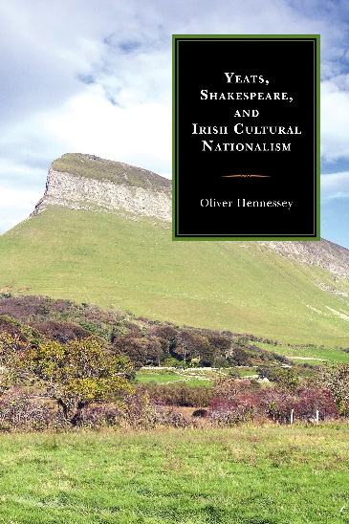

Dr. Oliver Hennessey, a professor at Xavier University of Louisiana, received an NEH Summer Stipend (FT-58542-11) in support of research and writing of Yates, Shakespeare, and Irish Cultural Nationalism (Farleigh Dickinson University Press, 2014).

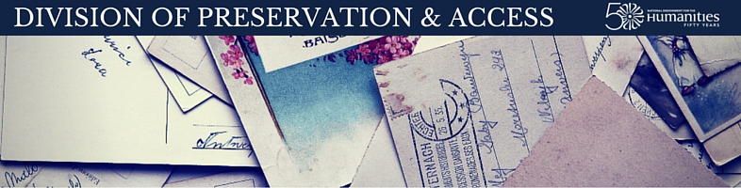

Preservation Assistance Grants

This program helps small and mid-sized institutions—such as libraries, museums, and colleges and universities—improve their ability to preserve and care for their significant humanities collections.

Since 2000, NEH has made nearly 1,900 awards for Preservation Assistance Grants (commonly known as PAGs) to institutions that want to improve their ability to preserve and care for their humanities collections. Institutions like:
- Libraries
- Museums
- Historical societies
- Archival repositories
- Cultural organizations
- Town and county records offices
- Colleges and universities

In all 50 states, the District of Columbia, and in Puerto Rico, PAG awards have enabled many small and mid-sized cultural repositories to hire consultants to do a preservation assessment; purchase preservation supplies, including shelving and archival folders; and acquire environmental monitoring equipment. PAGs also support cultural heritage institutions develop disaster or environmental monitoring plans, train their staffs in the care and storage of humanities collections, and best practices for cataloging and arranging and describing collections.

In addition to the Preservation Assistance Grant program, members of the HBCU community are encouraged to apply to other grant programs offered by the NEH Division of Preservation and Access.

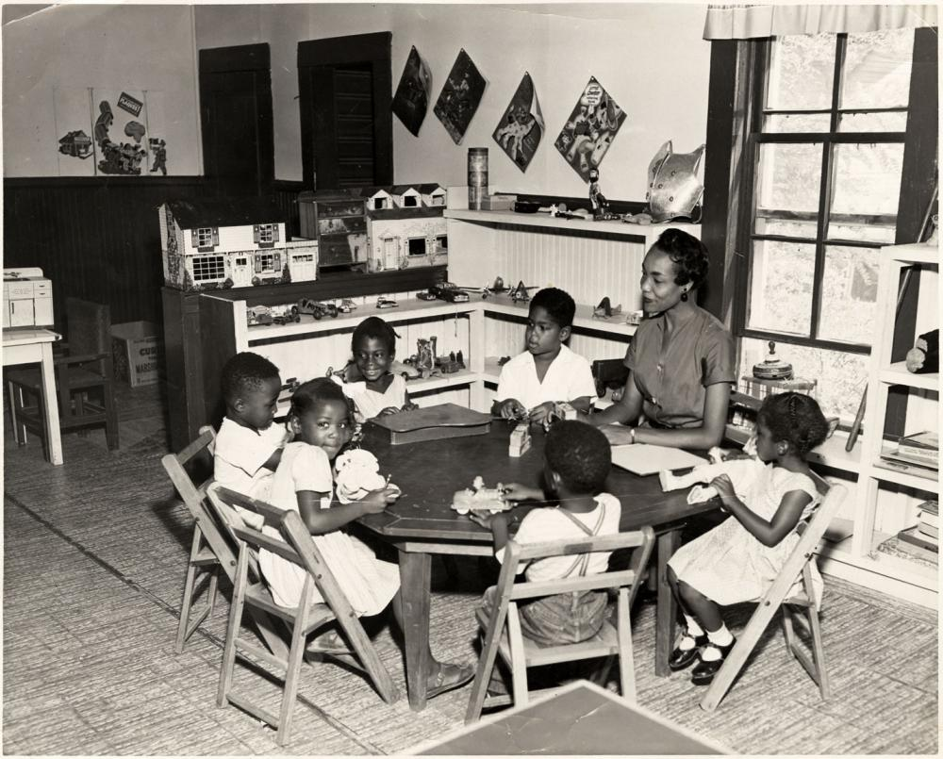

Shreveport children, from The DeArdis and Annie M. Belton Collection, Courtesy of Southern University at Shreveport. Southern University at Shreveport received an NEH Preservation Assistance Grant in support of a preservation assessment (PG-52101-13).

Humanities Access Grants

This program helps support capacity building for humanities programs that benefit one or more of the following groups: youth, communities of color, and economically disadvantaged populations.

Humanities Access grants establish or augment term endowments (that is, endowments whose funds are entirely expended over the course of a set time period) to provide funding for existing programs at institutions such as:
- Public libraries
- Local and regional museums
- Historical societies
- Community colleges
- HBCUs and tribal colleges
- Hispanic-serving institutions
- Archival repositories
- And other cultural organizations

Humanities Access grants are intended to seed longer-term endowment-building efforts.

Programs supported by Humanities Access Grants might include, for example, a summer project for teens at a local historical society; internships for Native American students at a tribal museum; or a Clemente course at a homeless shelter organized by a community college.

In addition to the Humanities Access Grants, members of the HBCU community are encouraged to apply to other grants offered through the NEH Office of Challenge Grants. Grant programs offered by the Office of Challenge Grants typically specialize in matching grants intended to inspire and augment fundraising by humanities institutions for the sake of their long-term stability.

Additional Grant Opportunities

In addition to the four grant programs described above, there are many other NEH grant programs that could suit your project. In many cases, applicants can compete concurrently. Grants are available in the following areas:

The Office of Digital Humanities (ODH) offers grant programs that address the ways that networked digital technologies have changed the way that we read, write, learn, communicate, and play. These changes are being addressed in fascinating ways by scholars from across the humanities, often working in collaboration with scientists, librarians, museum staff, and members of the public. This would include projects that explore how to harness new technology for humanities research as well as those that study digital culture from a humanistic perspective.

- Digital Humanities Advancement Grants (currently under development) support projects that consider experimental new paths or explore innovative ideas for using digital technology to improve research, teaching, and public engagement with the humanities. The program will have two deadlines per year.

- The Institutes for Advanced Topics in the Digital Humanities is a professional development program. These NEH grants support national or regional (multistate) training programs for scholars and advanced graduate students to broaden and extend their knowledge of digital humanities. Through these programs, NEH seeks to increase the number of humanities scholars using digital technology in their research and to broadly disseminate knowledge about advanced technology tools and methodologies relevant to the humanities. The directory of current and past opportunities is available on the ODH section of the website. Deadlines to apply to participate vary by the particular offering.

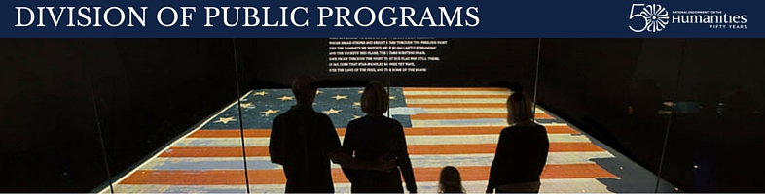

The Division of Public Programs supports projects that use perspectives from humanities scholarship to foster the exploration of significant questions about human history and culture. Grants fund programs that use creative approaches to humanities ideas to actively engage broad, diverse audiences. Projects transcend the mere recounting of factual information to thoughtfully pose a balanced, analytical investigation of the larger meanings of the subject and stimulate critical thinking.

- Public Humanities Projects grants support museum exhibitions; tours and public programs at historic places; and sustained yearlong community engagement projects such as forums, discussion programs, and lectures. Funding is offered at two stages in a project: planning and implementation. There are two deadlines each year, in early January and early August.

- Media Projects grants support documentary films and radio productions intended for national broadcast or distribution through the web. Funding is available for two phases of a project: development and production. There are two deadlines each year, in early January and early August.

- Digital Projects for the Public grants support websites, mobile apps, video games, virtual environments, and other digital platforms. Funding is offered at three project stages: discovery, prototyping, and production. The annual deadline is in early June.

Federal/State Partnership is the NEH office designated to work with the fifty-six state and jurisdictional humanities councils. Federal/State Partnership is a collaborative effort that links a national federal agency with the state and jurisdictional humanities councils. This partnership makes humanities education and lifelong learning readily available at the local level, uniquely tailored to local interests and needs and drawing upon local resources and experiences. To find out more about the state humanities councils near you, consult the state listing available on the NEH website.

The Peer Review process

As part of its review process, all applications submitted to NEH are reviewed by external reviewers to advise the agency about its merits. After the peer review, NEH staff comments on matters of fact or on significant issues that otherwise would be missing from these reviews, then makes recommendations to the National Council on the Humanities. The National Council meets at various times during the year to advise the NEH chairman on grants. The chairman takes into account the advice provided by the review process and, by law, makes all funding decisions. More information about the NEH peer review process may be found on the NEH website.

NEH is always looking for peer reviewers to participate in this process. If you’re interested in serving on an application review panel, please add your name via the online Panelist/Reviewer Information System (PRISM) database. And if there is a grant program for which you are particularly interested in serving as a peer reviewer, please feel free to send your contact information and résumé to the program’s e-mail address found in the application guidelines, noting that you are interested in being considered as a reviewer.

Internships

If you have a student who is interested in learning more about the work of the Endowment and is seeking an internship experience with one of our program or administrative offices, please have them visit the NEH Office of Human Resources page about our internship opportunities. On that page, students will find information about the application process as well as descriptions from the various offices and divisions about the type of work an intern would undertake during their time with us. We are accepting applications on an open continuous basis for volunteer student and other internships. While we are unable to provide paid internships at this time, we are able to provide valuable experience working in program and administrative offices of the Endowment.

Preparing a competitive application

NEH provides the following tips to prepare a competitive application:

- Talk with National Endowment for the Humanities staff
- Find the right program
- Read the guidelines carefully
- Study the samples
- Register with grants.gov
- Talk with colleagues, including the research or sponsored programs staff on your campus

Each grant program has a webpage with guidelines, samples of previously funded applications, and other resources. Make sure to carefully review these webpages.

When writing the application:
- Make a case for the project
  - Put it in context with a larger story
  - Highlight the humanities subject matter
  - Anticipate and address readers’ questions
  - Provide a detailed plan of work
- Address the Audience
  - Write for generalists and specialists
  - Communicate who the project is for
- Request feedback; apply again

NEH program officers also are available to read and respond to draft applications for many of the programs.

For more information

Applicants can use the NEH website to learn about grant programs and previously funded projects. Application guidelines for all programs are available on the website, as are sample application narratives and FAQs. Applicants may also wish to consult the NEH database of funded projects to learn about projects previously supported by NEH; you can search by grant program, humanities discipline, institution or state.

Applicants are encouraged to contact NEH program staff early in the application process. Program staff can help applicants identify appropriate NEH grant programs for a project, provide information on the application process, and, in some cases, respond to draft proposals.

Contact the main number or e-mail of an NEH Division or Office to be connected to a program staff member, or phone (202) 606-8400.

Division of Education Programs (202) 606-8500 | education@neh.gov
Division of Preservation and Access (202) 606-8570 | preservation@neh.gov
Division of Public Programs (202) 606-8269 | publicpgms@neh.gov
Division of Research Programs (202) 606-8200 | research@neh.gov
Federal/State Partnership (202) 606-8254 | fedstate@neh.gov
Office of Challenge Grants (202) 606-8309 | challenge@neh.gov
Office of Digital Humanities (202) 606-8395 | odh@neh.gov

