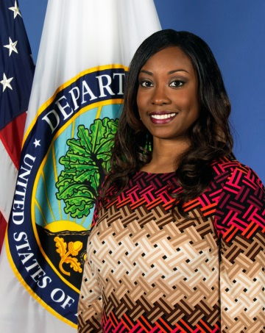
Tammi Fergusson
Program Analyst
White House Initiative on Historically Black Colleges and Universities

Tammi Fergusson is the Program Analyst in the office of the White House Initiative on Historically Black Colleges and Universities (WHIHBCUs). She is responsible for working directly with the Federal agency representatives and liaisons, instituted through Executive Order 13532, to strengthen the capacity of HBCUs through increased participation in appropriate Federal programs and initiatives.

Prior to her assignment at the WHIHBCUs, Ms. Fergusson served as the Education Program Specialist for several programs administered through the Department of Education including Race to the Top, Early Learning Challenge and the Improved Reentry Education grant program. Additionally, she worked on several interagency initiatives to develop grant programs and provide technical assistance to various entities throughout the educational spectrum. In 2014, she was awarded the U.S Department of Education Secretary’s Collaboration Award for her excellence in interagency work.

From 2007-2010, Ms. Fergusson was a National Literacy Trainer for Reading Is Fundamental® (RIF®), the nation's largest literacy nonprofit organization. She had the opportunity to train professionals and paraprofessionals nation-wide on various literacy programs that stressed the importance of integrating reading into everyday family life. In this role, she focused on at-risk populations and coordinated literacy events for African American, Tribal, and Migrant communities. Ms. Fergusson was awarded the Reading Is Fundamental® Gold Star for Outstanding Customer Service for three consecutive years.

Prior to working for RIF®, Ms. Fergusson was a Graduate Advisor for University of Maryland, University College where she provided college assistance and counseling to non-traditional students.

Ms. Fergusson graduated from Howard University with a Master of Science degree in Infant, Child, and Adolescent Development in Education, and from the University of Maryland, College Park, with a Bachelor of Science degree in Family Studies. Ms. Fergusson also has certifications in Federal Grant Management and Contracting Officers Representative.

