Joeletta Patrick, Manager, Minority University Research and Education Program
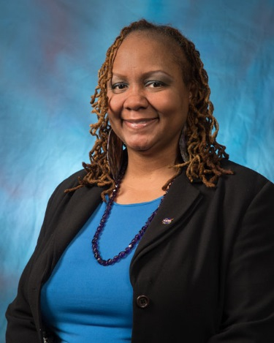
Credits: NASA
Joeletta Patrick is a native of Greensboro, N.C., where she attended North Carolina A&T State University and received a B.S. in electrical engineering. Upon graduation, she moved to Houston, Texas, and began her career in the NASA family at Johnson Space Center. She worked as a flight controller for the International Space Station in the Electrical Power System group.
Patrick's career has been marked by positions of steadily increasing responsibility, leadership and assumption of new challenges. In 2010, after working as a certified flight controller, she served as the education program manager of Johnson Space Center's Minority University Research and Education Program, or MUREP. Her leadership resulted in a JSC Group Achievement Award for outstanding achievement in aligning Johnson with NASA's goal to inspire, engage and educate and the JSC Superior Achievement Award for her outstanding leadership, development and integration.
In May 2011, Patrick was selected to serve as the Headquarters MUREP Education Fellow in Washington, DC. She worked with internal and external organizations, institutions, federal agencies, and the community through various Office of Education assignments. Her work reflected her commitment to leveraging university relationships and investments, growing the number of diverse students prepared to work in STEM-based fields, supporting STEM initiatives, and serving as a spokesperson for NASA's commitment to STEM. In September 2013, Patrick was selected as the Agency manager for MUREP at NASA Headquarters in the Office of Education.
Patrick holds a Masters of Business Administration from University of Maryland University College and enjoys volunteering in the community and serving in social and professional organizations. She is a member of the Society of Women Engineers, and Delta Sigma Theta Sorority Inc.
Joeletta’s complete bio can be found at:
https://www.nasa.gov/offices/education/leadership/patrick_bio.html

