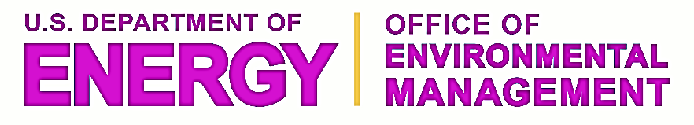
Minority Serving Institution Partnerships Program (MSIPP)

The Office of Environmental Management’s (EM) Minority Serving Institution Partnerships Program (MSIPP) supports research, education, training, and workforce development at Minority Serving Institutions (MSIs) in areas of science, technology, engineering, and mathematics (STEM).

MSIPP goals
- Enhance the role of minorities in EM's future workforce at DOE national laboratories and sites
- Fund competitive, collaborative applied research that is relevant to EM’s mission
- Support STEM education and internships
- Increase opportunities for MSIs to work with DOE national laboratories
- Leverage resources such as Laboratory Directed Research and Development funds and EM technology development funds to advance minority-focused opportunities

Program components
Annual competitive research solicitation for minority serving institutions
Student internships at U.S. Department of Energy national laboratories for undergraduates and graduate students
Hands-on research experience in EM-relevant disciplines

Budget
Projects are forward-funded to avoid disruption to research projects.
FY 2016: ~$8M
FY 2015: $7.5M
FY 2014: $7.1M

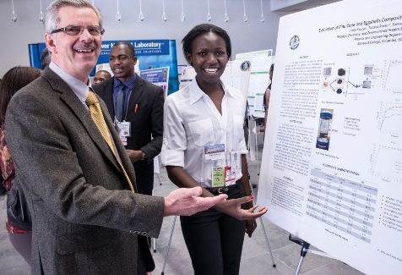

MSIPP metrics
Effectiveness of supported research | Number of new research collaborations between MSIs and DOE laboratories  Duration of new collaborations  Research results/products/technologies transferred to EM sites
Impacts on students | Number of students who complete MSIPP national laboratory internships  Number of MSIPP-impacted students who graduate with STEM degrees  Number of MSIPP-impacted undergraduates who pursue graduate STEM degrees  Student satisfaction with internships
Workforce impacts (long-term data) | Number/demographics of MSIPP-impacted graduates/postdocs hired into DOE’s technical and scientific workforce  Number/demographics of MSI faculty engaged in EM workshops, panels, reviews, etc.
Management
MSIPP is managed by Savannah River National Laboratory with assistance from the U.S. Department of Energy’s Savannah River Operations Office and with oversight from EM Headquarters (Mark Gilbertson, Deputy Assistant Secretary for Site Restoration; Kurt Gerdes, Director, Office of Soil and Groundwater Remediation).

Fiscal Year 2015
Competitive research awards
- 32 proposals received, 12 selected in the areas of soil and groundwater remediation, deactivation and decommissioning (D&D), and tank waste processing
Schools:
Alabama State University | Florida International University
Benedict College | Howard University
City University of New York | South Carolina State University
Florida A&M University | University of Nevada Las Vegas
National laboratory partners:
Oak Ridge National Laboratory, Pacific Northwest National Laboratory,
Savannah River National Laboratory
- Two-stage proposal reviews:
Technical Evaluation Committee assesses technical merit and planned scientific activities; 21 technical reviewers from five national laboratories and Savannah River Nuclear Solutions (SRNS)
Programmatic Evaluation Committee examines likelihood of proposal team meeting requirements and having sufficient resources to accomplish stated objectives; 4 reviewers from SRNL and EM
- MSI reporting:
Monthly budgets (invoices) to SRNS
Mid-year status updates
Annual final reports

MSIPP summer internships
Approximately 30 students from MSIs were placed in internships at SRNL, PNNL, ORNL, and Argonne National Laboratory in Summer 2015

Savannah River Environmental Sciences Field Station (SRESFS)
Supports hands-on applied environmental research and classroom training for students from South Carolina State University (SCSU) and regional MSIs. SCSU led this program ($500K) and SRNL is a partner on three continuing research projects ($200K). The 2015 SRESFS program supported 5 research interns and 21 students in courses. Research projects included:
  - Contaminant attenuation by reductive minerals
  - Assessment of Savannah River Site hydrology
  - Regional deposition of mercury and other contaminants

Fiscal Year 2016
- A competitive research solicitation will be issued in November for multi-year awards (single-year awards were issued in FY 2015)
- SRNL is developing an integrated MSIPP summer internship program with participation from multiple national laboratories
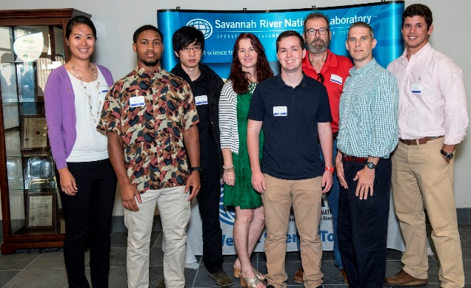
Contacts
SRNL program manager: Connie Yung, connie.yung@srnl.doe.gov, 803-725-9032
EM program manager: Karen Skubal, karen.skubal@em.doe.gov, 301-903-6524
MSIPP website: http://srnl.doe.gov/msipp/index.htm

