HBCUs: Innovators for Future Success: STEM, Partnerships and Entrepreneurship
2015
2015 HBCU Week Conference Biography Book
The biographies and pictures of the conference panelists, moderators, and participants are listed by alphabetical order. *Others will be added as they become available.
White House Initiative on Historically Black Colleges and Universities

Table of Contents
Philip Alberti 1
Pamela G. Alexander 2
Brenda Allen 3
Kojuan Almond 4
Laz Alonso 5
Juan Amador 6
Jared C. Avery 7
Traci Lynn Blackwell 8
Tanaga A. Boozer 9
Marcia Boyd 10
Reginald Brothers 11
C. David Brown 12
Carlton Brown 13
Melissa Gray Brown 14
Quincy Brown 15
Legand L. Burge, III 16
Angela Burt-Murray 17
Tiffany Bussey 18
Michael Byron 19
Samuel D. Cargile 20
Marvin Carr 21
Bria Carrithers 22
Valarie Clark 23
Roslyn Clark Artis 24
John Clement 25
Anitra Collins 26
Erica McGeachy Crenshaw 27
Benjamin Crump 28
Sharifa Dickinson 29
Arne Duncan 30
Leeanne Dunsmore 31
Joan Ferrini-Mundy 32
Diane J. Frasier 33
Wayne A. I. Frederick 34
George T. French 35
Athena Fulay 36
Juan Gilbert 37
Evelynn M. Hammonds 38
Chanelle Hardy 39
Honorable LaDoris “Dot” Harris 40
William R. Harvey 41
Ben Hasan 42
Brian O. Hemphill 43
Damien Hooper-Campbell 43
Rick Hughes 44
Reginald E. Humphrey 45
Melissa Ingram 46
Rinaldi Jacobs, Sr. 47
Anneka Jenkins 48
David J. Johns 49
Brian Johnson 50
Lonnie G. Johnson 51
Ryan Kelsey 52
Karla Loor Kitchel 53
Julie Kirk 54
Douglas Kramer 55
Courtney Lamar 56
Reginald K. Layton 57
Lisa Lee 58
Torian Lee 59
Joe Leonard 60
David Levin 61
Gayle Lomax 62
Tizoc S. Loza 63
Jacquelyn Madry-Taylor 64
Pamela J. Maimer 65
Emily Mann 66
Harold Martin 67
Zola Mashariki 68
Ron Mason 69
Travis Mason 70
Willie E. May 71
Derek McGowan 72
Stacy Milner 73
James T. Minor 74
Kelly Minton 75
Ted Mitchell 76
Vela Mitchell 77
Tameka Montgomery 78
E. Elaine Moore 79
Loretta A. Moore 80
Charles Moses 81
Omar Muhammad 82
Charlie Nelms 83
Dava Newman 84
Joseph Nsengimana 85
Mildred Huff Ofosu 86
Sharon Patterson 87
Maci Peterson 88
Claudia Rankins 89
Chera Reid 90
Lee Rivers 91
Earl Robinson 92
Elwood Robinson 93
Nancy Rodriguez 94
Lamman Rucker 95
Stephanie Santoso 96
Megan Smith 97
Tiffany Smith-Anoa’i 98
Lenny Springs 99
Wayne Szanfranksi 100
Asaad “Tibias” Thorne 101
Henry Tisdale 102
Ivory Toldson 103
Scott Trapp 104
Francis Tuluri 105
Hannah Valentine 106
Michael P. Verchot 107
Beverly Wade-Hogan 108
Michael Wallace 109
Don Watson 110
Charles A. Weatherford 111
David Weaver 112
Joseph Wells 113
Katherine Wheatle 114
Mary N. Whigham-Jones 115
Leon White 116
Harry Williams 117
Kezia Williams 118
David Wilson 119
Angela Woods 120
Chad Womack 121
Joseph Wyatt 122
Dorothy Cowser Yancy 123
Geoffrey H. Young 124

Philip Alberti

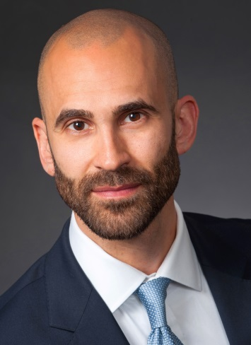
As the Association of American Medical Colleges’ (AAMC) Senior Director for Health Equity Research and Policy, Philip M. Alberti, PhD, supports the efforts of academic medical centers to build an evidence-base for effective programs, protocols, and partnerships aimed at ameliorating inequalities in health and healthcare through research. Alberti is responsible for working with AAMC’s constituents to elevate the status of community-partnered and health equity-related research efforts, identifying emerging funding sources and policy implications for such projects, and disseminating findings to achieve the broadest possible impact. Prior to joining the AAMC in 2012, Alberti led research, evaluation, and planning efforts for a Bureau within the New York City Department of Health and Mental Hygiene (NYC DOHMH) that works to promote health equity between disadvantaged and advantaged neighborhoods. Alberti holds a PhD degree in Sociomedical Sciences from Columbia University’s Mailman School of Public Health and was a National Institute of Mental Health Fellow in the Psychiatric Epidemiology Training program.

Pamela G. Alexander

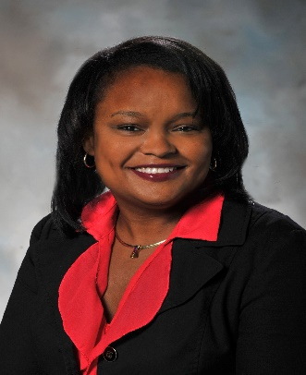
Pamela Alexander is Director of Community Development for Ford Motor Company Fund, the philanthropic arm of Ford Motor Company. Prior to her appointment in the Ford Fund, Pamela held a variety of positions in the Ford Motor Company Governmental Affairs office. Her experience has included policy development on strategic issues such as the environment and privacy. She has worked on legislative and community issues at the state level and acted as manager of the Company’s PAC and grassroots activities. Pamela also served as Ford’s governmental affairs manager for the Southeast Michigan region.

Ms. Alexander joined Ford in 1990 and began her career in the Controller’s Office in areas such as Marketing and Sales, Product Development and Corporate Finance. A native “Michigander,” Ms. Alexander holds a bachelor’s from Georgetown University and a master’s degree from Columbia University. Ms. Alexander dedicates her time to serve on various non-profit boards including the GRAMMY Foundation, the Memorial Foundation, the Congressional Black Caucus Foundation, the Special Contribution Fund of the NAACP, and the Charles H. Wright Museum of African American History. She has received numerous honors that include, “High Heels in High Places” award by the Trumpet Foundation, a “Corporate Trailblazer” award from Rainbow PUSH, the Community Service award from the Arab American and Chaldean Council, and was featured in Ebony magazine’s Speaking of People column and African Americans on Wheels as one of the auto industry’s most influential African-American women.

Brenda Allen

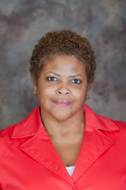
Dr. Brenda A. Allen was named Provost and Vice Chancellor for Academic Affairs December 15, 2008. Dr. Allen is also a tenured member of the faculty, holding the title of Professor of Psychology in the Department of Behavioral Sciences and Social Work. Prior to her appointment, Dr. Allen held the position of Associate Provost and Director of Institutional Diversity at Brown University in Providence, Rhode Island. Prior to joining Brown University, Dr. Allen held a number of academic and administrative positions at Smith College in Northampton, Massachusetts. Prior to her tenure at Smith College, Dr. Allen spent three years at Yale University in New Haven, Connecticut where she held several positions, including Postdoctoral Fellow, Postdoctoral Associate in the Department of Psychology, and Lecturer in the Departments of Psychology and African American Studies. Dr. Allen holds a bachelor’s degree in Psychology from Lincoln University in Lincoln, PA, a master’s degree in Experimental Psychology and a doctorate in Developmental Psychology, both from Howard University in Washington, DC.

Kojuan Almond

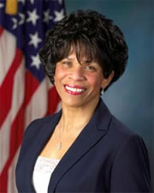
Kojuan Almond recently finished the Senior Executive Service (SES) Program, which is the most prestigious management program in the United States Government. She has held a number of increasingly more challenging positions during her federal tenure, including: Generalist Claims Representative, Operations Supervisor, Area Systems Coordinator, Staff Assistant to the Deputy Regional Commissioner, Project Manager in the Center for Service Delivery, Executive Assistant to the Regional Commissioner, Regional Recruitment Manager, Regional Communications Director, Executive Assistant in the Office of the Chief Strategic Officer in Headquarters, Deputy Assistant Associate Commissioner in the Office of International Operations, Director of Human Capital at the United States Environmental Protection Agency, and Deputy Associate Commissioner in the Office of Income Security Programs, which is part of the Office of Retirement and Disability Policy. She is the Associate Commissioner for Civil Rights and Equal Opportunity. Kojuan is married to Adolphus Almond. She has a daughter who is currently finishing a master's degree program and preparing to enter law school, and three wonderful stepchildren, including one who is also a part of the Social Security family in the Atlanta region.

Laz Alonso

Laz Alonso stars as Det. Billy Sands in NBC’s “Mysteries of Laura.” Alonso’s television credits include lead roles in NBC’s “Deception” and A&E’s “Breakout Kings.” On the film side, he recently played the lead in “Battle of the Year,” opposite Josh Holloway, Josh Peck and Chris Brown. In 2011, Alonso starred in the hit romantic comedy “Jumping the Broom” for which he received a NAACP Image Award for outstanding actor in a motion picture and was also nominated for a BET best actor award. Prior to “Jumping the Broom,” he co-starred in the highest-grossing film of all time, James Cameron’s “Avatar.” Alonso also starred in Spike Lee’s World War II film “Miracle at St. Anna.” Alonso executive produced and starred opposite Danny Glover in Alan Jacobs’ “Down for Life”, which received much acclaim at the Toronto Film Festival. Born and raised in Washington D.C., Alonso always knew he wanted to be an actor. He graduated from the prestigious Howard University School of Business, earning a B.A. in business administration with a concentration in marketing. After college, he worked on Wall Street as an investment banker. He now splits his time between New York and Los Angeles.

Juan Amador
Juan Amador is a director and group program leader in diversity policy and programs (DPP) of the Association of American Medical Colleges (AAMC). Juan leads the strategic direction and provides programmatic leadership for the Group on Diversity and Inclusion (GDI). He is also responsible for developing services, tools, and resources that directly support leaders in academic medicine working to integrate diversity across mission areas. Juan has over 10 years of experience in recruitment and outreach to special populations, developing strategic priorities and partnerships, and facilitating the work of national committees. Prior to the AAMC, Juan worked for the National Prevention Information Network of the Centers for Disease Control and Prevention. He earned his B.A in Health Science and Policy at the University of Maryland Baltimore County.

Jared C. Avery

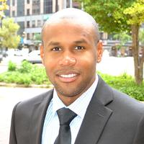
Jared Avery is the Associate Director for the Office of Access and Success (OAS) at the Association of Public and Land Grant Universities. In this capacity, he provides comprehensive support to the Vice President of the Office for Access and Success in efforts regarding equity, access, and educational excellence for college student populations and minority-serving institutions. Additionally, he manages a collaboration of partnerships and initiatives; create and support original research; and engage in a host of other activities that support the mission of the office. Avery has published articles and a report focused on the persistence of Black male college students and the implantation of senior-year college readiness courses. Avery is a three-time graduate of Louisiana State University, earning a bachelor’s and master’s degrees in psychology and education with an emphasis in higher education and student affairs, respectively. In 2014, Dr. Avery completed his doctoral degree in educational leadership and research.

Traci Lynn Blackwell

Traci Lynn Blackwell is Senior Vice President of Current Programs at The CW Network. Traci currently oversees the day-to-day production of some of the most buzzed-about shows on television, including breakout dramas Vampire Diaries, The Originals, Supernatural, and the 2015 Golden Globe and Peabody award winning new hit, Jane The Virgin. The CW series’ sought-after young stars have graced major magazine covers from Entertainment Weekly to TV Guide, Seventeen, Nylon, In Style, Cosmo, Elle, Vogue and many more. Blackwell cultivated her expertise in network TV programming working for UPN. During her stint there, Blackwell worked on the production of several sitcoms, such as The Parkers and Moesha. Traci began her career at UPN as an assistant, and soon began working for then-President of Entertainment Tom Nunan, who served as a mentor and encouraged her aspiration to become a current programming executive. Prior to UPN, Blackwell worked as an assistant to Academy Award nominated producer/director Reginald Hudlin. Blackwell is an active member of the National Association of Television Arts and Sciences (NATAS), the organization responsible for the Emmys; Colour TV, a networking and support group for television executives; and the Spelman College Alumni Association. She has been a speaker for youth empowerment organizations such as Disney Dreamers Academy and Hill Harper’s Manifest Your Destiny Foundation, as well as a speaker at the Essence Women’s Conference. Traci is a native of Silver Spring, Maryland. She earned a bachelor's degree in English from Spelman College in Atlanta, GA and a master’s degree in Communications from Emerson College in Boston, MA.

Tanaga A. Boozer
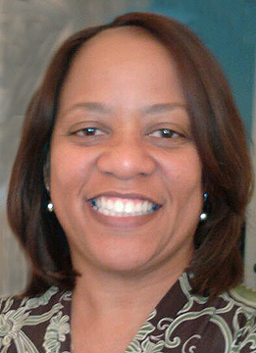
Tanaga Boozer is a Program Advisor in the Office of Education and Outreach at the USPTO where she develops and implements intellectual property (IP) educational outreach programs and collaborations with external organizations, academic institutions and federal agencies. Prior to joining the USPTO, Ms. Boozer was the Director of Technology Transfer at Florida A&M University with a dual teaching appointment in the College of Pharmacy and Pharmaceutical Sciences. She worked with faculty researchers to disclose, file and license their patented inventions. While at FAMU she also developed and taught a graduate level course in intellectual property for scientists and engineers as well as hosted a summer invention camp for middle and high school students. Other past work experience includes positions at Procter & Gamble, Insmed Biopharmaceutical Company, the National Institute of Standards and Technology and the USPTO (where she served as a chemical patent examiner). Ms. Boozer earned her B.S. degree in Chemistry from Rust College, M.B.A. in Management from Prairie View A&M University, J.D. from the University of Mississippi and the LL.M. in Intellectual Property from George Washington University.

Marcia Boyd
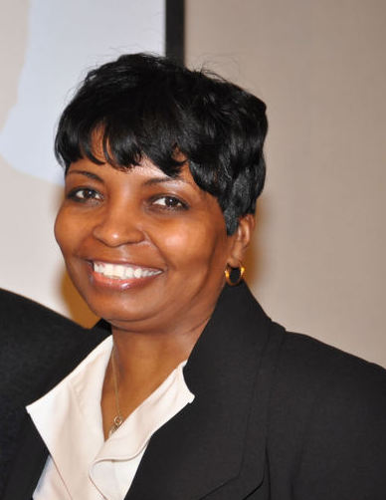
Dr. Marcia Boyd currently serves as the Director of the Minority Serving and Under Resourced Schools Division and Deputy Director of the School Experience Group in Federal Student Aid. Dr. Boyd joined the MSURSD team in December 2012 and has provided significant leadership to numerous special projects. Marcia has over twenty years of higher education experience in four year publics and privates, undergraduate and graduate institutions in significant leadership roles. Those roles have included chief financial aid office, Manager of Student Accounts, Assistant Director of Financial Aid, Director of Financial Aid, Associate Vice President for Student Affairs, while serving at the College of William and Mary College, Greensboro College, Christopher Newport University, and Hampton University. Marcia’s most recent service prior to joining Federal Student Aid was at Trinity Washington University , Washington DC where she served as an Assistant VP for Enrollment Services and Florida A & M University where she served as Director of Financial and eventually was promoted to Associate Vice President for Student Affairs. . Marcia has extensive experience in enrollment management, financial aid, admissions, recruitment, registration, student judicial affairs, intercollegiate athletics, new student orientation programs, veteran and military affairs and human resource development.
Dr. Boyd is recognized at the state, regional and national levels for her expertise in the areas cited previously and has provided higher educational consultation services to numerous colleges and universities, the U.S. Department of Education, private companies and other higher educational organizations with regard to institutional compliance of Title IV statutes and regulations, training, technology utilization, systems processing and functionality, communication, staffing, and organizational structure.
Marcia earned a Bachelor of Business Administration (BBA) from Baruch College of New York, Master of Arts in Human Resource Development from The George Washington University of Washington, DC and completed her doctoral studies in Higher Education Administration with The George Washington University, fall 2013.

Reginald Brothers (Invited)

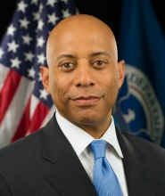
Dr. Reginald Brothers was confirmed by the U.S. Senate on April 7, 2014, for the position of Under Secretary for Science and Technology at the U.S. Department of Homeland Security (DHS). As Under Secretary for Science and Technology, Dr. Brothers is the science adviser to the Secretary and Deputy Secretary of Homeland Security and is responsible for oversight and management of the Science and Technology Directorate (S&T), the Department’s primary research and development arm and technical core. Dr. Brothers is a science and technology leader and expert with more than 20 years of demonstrated success across the private and public sectors. He has held a variety of positions within the scientific and technological community that demonstrate his leadership and technical aptitude. This includes his prior service as a Technical Fellow and Director for Mission Applications in the Communications and Networking Business Area at BAE Systems, as a member of the Board on Army Science and Technology within the National Academy of Sciences, and as a Program Manager for the Defense Advanced Research Projects Agency. This also includes his experience as a Group Leader at the Charles Stark Draper Laboratory and as Chief Architect at Envoy Networks, a successful 3G wireless start-up company. Dr. Brothers received a B.S. in Electrical Engineering from Tufts University, an M.S. in Electrical Engineering from Southern Methodist University, and a Ph.D. in Electrical Engineering and Computer Science from the Massachusetts Institute of Technology.

C. David Brown
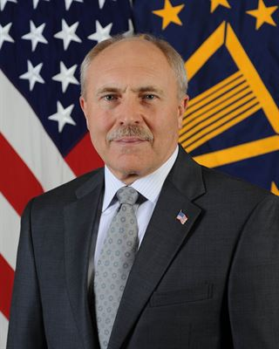
Dr. C. David Brown is the Deputy Assistant Secretary of Defense for Developmental Test & Evaluation (DASD(DT&E)) and Director, Test Resource Management Center (TRMC). As the DASD (DT&E), he serves as the principal advisor on developmental test and evaluation to the Secretary of Defense (SECDEF) and the Undersecretary of Defense for Acquisition, Technology and Logistics (USD(AT&L)). Dr. Brown is responsible for DT&E policy and guidance in support of the acquisition of major Department of Defense (DoD) weapons systems, and providing advocacy, oversight, and guidance to the DT&E acquisition workforce. In Dr. Brown's role as Director, TRMC he advises the SECDEF and USD (AT&L) on matters pertaining to the DoD's Major Range and Test Facility Base (MRTFB), the Nation's critical range infrastructure for conducting effective test and evaluation (T&E). Additionally, he reviews and certifies proposed T&E budgets of Military Departments and Defense Agencies, administers the Central Test and Evaluation Investment Program (CTEIP), and oversees the DoD program for T&E science and technology. Dr. Brown became a member of the Senior Executive Service in 1999, holds two patents, and has authored numerous technical papers. He is a registered Professional Engineer and Certified Test and Evaluation Professional, was a member of the Army Acquisition Corps, and is a retired Army Reserve Colonel. He has a PhD in electrical engineering from the University of Delaware, and a MS in National Resource Strategy from the National Defense University Industrial College of the Armed Forces. He is an active member of the International Council on Systems Engineering and the International Test and Evaluation Association.

Carlton Brown

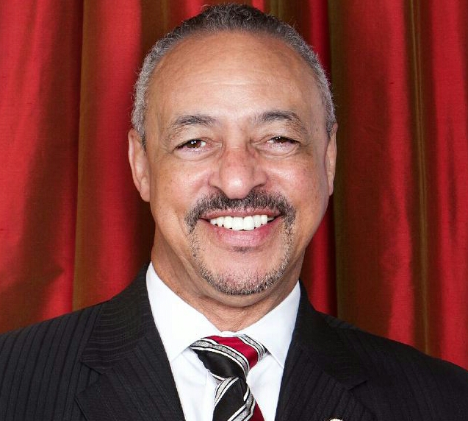Dr. Brown retired from the presidency of Clark Atlanta University in June of 2015 after seven years of service preceded by one year as Executive Vice President and provost. He previously served as Special Assistant to the Chancellor of the University System of Georgia for the implementation of system-wide change initiatives. His first presidency was at Savannah State University from 1997-2006. Dr. Brown spent ten years in the administration of Hampton University as a dean of education, dean of liberal arts, then dean of the graduate college and vice president for planning.

Known as an agent of change and a builder of institutional communities, Dr. Brown has successfully re-engineered programs and schools throughout his career. He has led the development of institution-turning strategic plans at all three institutions and the reclamation of cultural history. Hampton 2000 in 1994 built the infrastructure and process for increased research and the development of Ph.D. programs. At Savannah State University, his plan led to first accreditations for Business and Mass Communications, Increased funded research, completely rebuilt student housing and strong community impact. At Clark Atlanta University, a first plan focused on infrastructure improvement and process renewal. The second which is in operation now focuses on significant change in academic programs, changed student profiles, broader research and entry into the fields of innovation and tech entrepreneurship with the building of the Center for Innovation and Entrepreneurial Development, the Center for Undergraduate Research, and a radically new approach to general education. At CAU, he re-established the Phylon Journal and built the DuBois Institute.

He has served on the boards of NAFEO, UNCF, the Holmes Group, and AACTE. Currently serves on the Advisory Board of the Epicenter at Stanford University, Momentus, and is a member of the AGB Council of Presidents. In civic service, Dr. Brown has served as the Chair of the Board of Directors of the Youth Futures Authority, the Savannah Economic Development Authority, and vice chair of the Hampton Virginia School Board.

Dr. Brown’s current activities include support of greater HBCU involvement in innovation and entrepreneurship, deeper engagement of people of color in sustainability, and continued improvement in the preparation and assessment of teachers. He holds a Bachelor’s Degree in English and American Studies as well as the Ed. D. in Multicultural Education and Organizational Change, both from the University of Massachusetts at Amherst.

Melissa Gray Brown

Melissa Brown is Senior Manager, at The Home Depot. Since joining the Atlanta-based company in 2003, Brown has played an integral role in leading the strategy for the African American consumer segment as well as key elements of the Hispanic consumer segment. Brown is responsible for a variety of integrated partnerships that include “The Steve Harvey Morning Show” and “The Tom Joyner Morning Show,” as well as digital, social, mobile and grassroots efforts.

Under the later categories, Brown has implemented an award winning social media platform to develop “The Home Depot’s “Retool Your School” grant program designed to make sustainable improvements to the campuses of Historically Black Colleges and Universities. This campaign received the American Advertising Federation’s 2013 Mosaic Award in the area of “Multiethnic Interactive Media.”

For her outstanding work in handling a wide-ranging portfolio of bold and creative marketing strategies, Brown has earned recognition from within the industry and beyond. In 2007, she received the Rising Star Award from the ADCOLOR Coalition, a leading trade association that recognizes outstanding achievement among multicultural executives within the advertising, marketing and media industries. Recently, she was recognized as one of Black Enterprise Magazine’s Top African American women in Marketing and Advertising.

Brown holds a Bachelor of Business Administration degree in Marketing and is the proud mother of three sons.

Quincy Brown

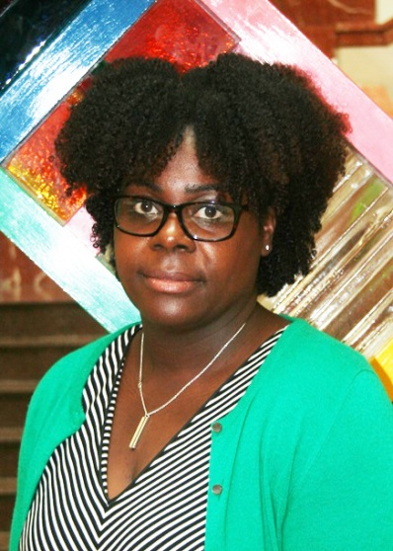
Dr. Quincy Brown is an American Association for the Advancement of Science, Science & Technology Policy Fellow at the National Science Foundation in the Division of Computer and Network Systems, Directorate for Computer and Information Science and Engineering (CISE/CNS). She earned her Ph.D. in Computer Science from Drexel University. She is a recipient of the Computing Community Consortium (CCC) CI Fellows Postdoctoral Research Fellowship award and was a National Science Foundation GK-12 and Bridges to the Doctorate Fellow. As a GK-12 Fellow she taught and developed STEM curricula for middle school students. Prior to the fellowship, Dr. Brown was an Assistant Professor of Computer Science at Bowie State University. Her research interests include Mobile HCI, CS Education, and Broadening Participation in Computing. In 2011she founded Girl Who Will, a summer program for middle and high school girls. Each summer girls engage in activities including game design, mobile app development, wearable computing, and 3D printing. Through her research, Dr. Brown seeks to identify methods of facilitating human interaction with advanced technologies, including mobile devices, to support learning. Dr. Brown’s current projects include exploring the ways in which young children use touch and gesture interactions with mobile devices, first responder’s use of mobile devices during emergency evacuation, and modeling inquiry behaviors on mobile devices.

Legand L. Burge, III

Dr. Burge's research interests lie in the field of distributed computing. The primary thrust of his current research is in global resource management in large-scale distributed systems. In particular, he is interested in middleware technology to support scalable infrastructures for pervasive environments capable of servicing a very large number of small (possibly mobile) distributed and embedded devices efficiently. He is also interested in the application of distributed high performance computing to solve computational science problems in Biology, Physics, and Chemistry. Dr. Burge is currently the director of the Distributed Systems Research Group (DSRG) and associate director of the Center for Applied High Performance Computing at Howard University. Dr. Burge is also interested in Computer Science Education and Diversity, and Tech Innovation and Entrepreneurship. Prior to coming to Howard University Dr. Burge worked for the National Security Agency as a Computer Analyst for 5 years, and as a computer consultant for several years. Dr. Burge's previous research includes consistency management in distributed databases, and message passing libraries for distributed parallel computing. The work on consistency management is aimed at developing lightweight protocols that communicate using epidemic algorithms. The distributed parallel computing work consisted of the design and development of an actor-based message passing and thread migration package for Java. The package was used to design a campus wide non-dedicated meta-computer that distributed, and performed load balancing of computations based on CPU cycle stealing.

Angela Burt-Murray

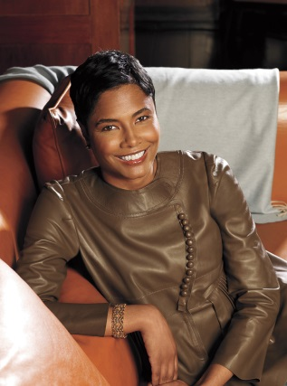
Angela Burt-Murray is a programming consultant with Magic Johnson’s cable network ASPiRE and the co-founder of Cocoa Media Group, a digital media company which launched CocoaFab, CocoaStyle and CocoaFab.TV to feature original video series and fashion, beauty and lifestyle content for young women of color.

Prior to launching CMG, Angela was the editor-in-chief of ESSENCE magazine and oversaw the editorial direction as steward of ESSENCE’s print, online and consumer marketing strategy from 2005-2010. She also expanded the ESSENCE brand into books, live events and created co-branded news and entertainment specials for CNN and TV ONE. She has also served as executive editor of TEEN PEOPLE and HONEY magazines.

Angela also serves as a co-host of EXHALE, a talk show on ASPiRE. She is the co-author of the novel, The Vow, which was turned into the Lifetime movie “With this Ring” starring Gabrielle Union and Jill Scott. She also authored the mystery novel Games Divas Play. She has frequently appeared on CNN, The Steve Harvey Morning Show, Good Morning America, MSNBC and The Today Show.

A graduate of Hampton University, Angela resides in Atlanta with her husband and their two children.

Tiffany Bussey

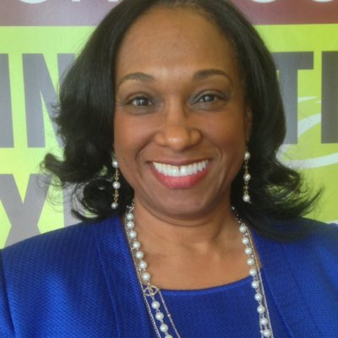
Dr. Tiffany Rogers Bussey is the founding Director of the Morehouse College Entrepreneurship Center, a global model for providing small business support in the areas of organizational management infrastructure development and process improvement. As Director, Dr. Bussey manages strategic terms of faculty, staff and consultants to achieve the goals of the Center, which is to assist in the development of minority entrepreneurship through scholarly research, training and consulting services. Dr. Bussey earned her doctorate in business administration and Masters of Science degree in strategic management from Edinburg Business School, Heriot-Watt University in Scotland. Dr. Bussey is a Project Management Professional, Certified Quality Auditor, Certified Training Presenter, and a Certified Teacher of Entrepreneurship. Her research interest intersects the areas of leadership behavior and strategic change in small firms.

Michael Byron

Michael Byron leads Walmart’s critical initiative to source $20 billion with women-owned U.S. businesses by 2016. Byron’s team managed Walmart’s 2014 spending of nearly $13.5 billion with approximately 3,000 diverse-owned businesses. Under his leadership, Walmart has been recognized for providing the best opportunities to woman-owned and multicultural businesses. Byron served from 2008-2012 as vice president of supplier diversity at SUPERVALU, Inc., a U.S. wholesale and retail grocer with annual sales of $44 billion. While at SUPERVALU, Michael increased the number of diverse suppliers by 5 to 10% annually and added $425 million in supply chain spending with diverse-owned businesses.

Samuel D. Cargile
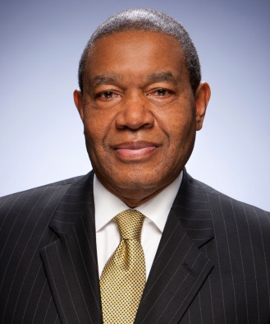
Dr. Cargile joined Lumina Foundation in 2001. He is one of the architects of “Achieving the Dream: Community Colleges Count” and led its successful transition to Achieving the Dream, Inc., an independent nonprofit organization that is now leading a national reform network of almost 200 colleges in 32 states and the District of Columbia dedicated to student success and completion. Currently, he manages the Foundation’s grants budget, serves as liaison to the City of Indianapolis, and as equity counsel and strategy advisor to the CEO. Previously, he served as a program officer at the Wallace Foundation in New York City and Lilly Endowment in Indianapolis. He has lived in Kimberley, South Africa where he served as a community college consultant (with SIPU International of Stockholm, Sweden) to the Department of Education, Training, and Arts and Culture of the Northern Cape Province. Other positions he has held include Executive Assistant to the Chancellor and Assistant Vice Chancellor for the Division of Academic Support Services at the University of Wisconsin Oshkosh, Director of the Office of Minority Education at the American College Testing Program in Iowa City, and Director of TRIO programs at the Milwaukee School of Engineering. He is a former national education policy fellow of the Institute for Educational Leadership at George Washington University in Washington, DC and higher education policy analyst in the Office of the Assistant Secretary for Planning, Budget and Evaluation, U.S. Department of Education, Washington, DC. Dr. Cargile is a native of Milwaukee and received his Ph.D. from the University of Wisconsin Milwaukee.

Marvin Carr

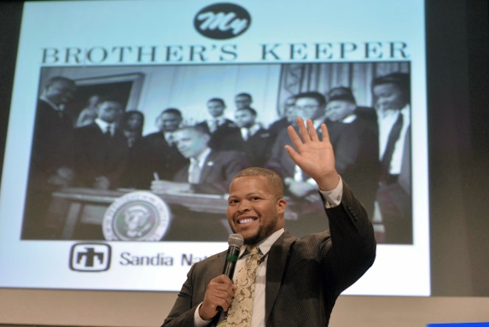
Dr. Marvin D. Carr is the Policy Advisor for STEM Education, Innovation and Diversity to the U.S. Chief Technology Officer, Megan Smith, within the White House Office of Science and Technology Policy. In this capacity, he works with Federal agencies, local leaders, the business community, and academia to support access to Science, Technology, Engineering, and Mathematics (STEM) for all Americans, especially those on the margins. Part of his work involves leveraging local engagement to enhance the STEM and Innovation aspects of the White House’s My Brother’s Keeper Initiative, which promotes opportunity for boys and young men of color and other young people.
Before he came to the White House, Marvin worked with schools and government in Baltimore to implement STEM training and tutoring for inner city youth and their parents. Marvin has a Bachelor of Science degree in Electrical Engineering from Morgan State University, a Master of Science degree in Systems Engineering from the University of Maryland, Baltimore County, and his Doctorate in Electrical Engineering from Morgan State. His research explores the relationship between race, gender, culture and cognition, and their impact on success in educational math software programs. Dr. Carr is a Kapor Fellow, a Fellow of the Partnership for Public Service, and an active member of the National Society of Black Engineers (NSBE) and a national leader in the Kappa Alpha Psi Fraternity, Inc.

Bria Carrithers

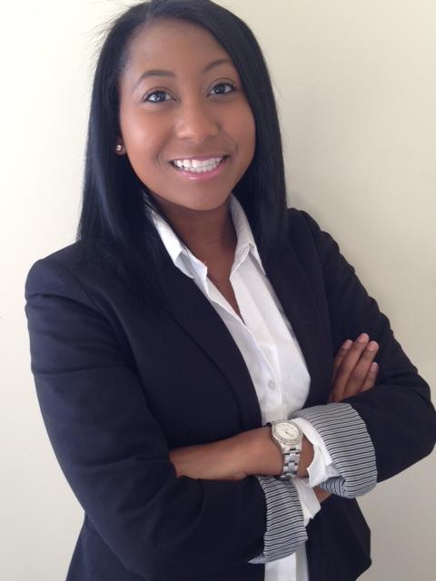
Bria K. Carrithers is currently a graduate student at Hampton University’s Graduate College pursuing her Master’s Degree in Medical Sciences. Before attending Hampton University, Bria was a Biology/Pre-Medicine major at Spelman College. Some of her activities at Spelman including being a Children’s Healthcare of Atlanta volunteer at the Hughes Spalding site, a TeenAngels Society Mentor for the Spelman Chapter, a Spelman STEM Scholar, Spelman College’s Health Careers Club Vice President, an award recipient of the undergraduate research award at the 2013 Curtis Parker Symposium at Morehouse School of Medicine, and the scholarship recipient of The Barbara H. Ferguson Scholarship in Biology. Carrithers was also a member of the inaugural class of 2014HBCU All Stars. Bria’s career goal is to become an Internal Medicine physician, specializing in hematology and oncology. In this profession she will have a chance to specifically focus on health disparities and diseases that plague African Americans and other minorities.

Valarie Clark

Roslyn Clark Artis

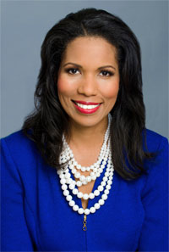
Dr. Artis is a graduate of Vanderbilt University in Nashville, Tennessee, where she earned her Doctorate in Higher Education Leadership and Policy. She received her Juris Doctorate degree from West Virginia University College of Law in Morgantown, West Virginia, and her Bachelor of Arts degree in Political Science from West Virginia State University in Institute, West Virginia. The consummate professional, Dr. Artis has extensive experience in university fundraising and holds a Certificate of Fundraising Management from Indiana University. She has also earned a Certificate of Mastery in Prior Learning Assessment from DePaul University’s School of Continuing & Professional Education.

In February, 2014, Dr. Artis was appointed unanimously by the Board of Trustees as the 13th President of Florida Memorial University. She is the first woman President in the University’s 136 year history. During her short stint as Acting President at Florida Memorial University, Dr. Artis provided immeasurable leadership and direction to the University family at all levels. She has become well-acclimated to the South Florida community, and has been appointed to multiple community and corporate boards and associations, increasing involvement and exposure of the University significantly. On campus, Dr. Artis has spearheaded a series of new and innovative programs for students and is diligently striving to improve corporate and community relations and endowment initiatives for the institution.

Throughout her career, Dr. Artis’ extensive academic experience and accomplishments have been widely accepted and highly successful. For nearly a decade, she served in numerous roles at Mountain State University; including Director of Legal Studies, Senior Academic Officer for Distance Education, Vice President of University Advancement, Executive Vice President & Chief Academic Officer, and the University’s Provost. Her responsibilities included the management and supervision of all academic courses and programs for the University; including its distance education offerings, branch campuses, sites and centers, as well as Institutional Research and Assessment.

Dr. Artis’ academic interests have included student retention, particularly as it relates to adult and non-traditional students, academic and co-curricular support structures in alternative learning modalities, strategic planning, institutional effectiveness and executive leadership.
Prior to embarking on a career in academia, Dr. Artis enjoyed an active general litigation practice for eight (8) years. She served as a partner in Assessment by Design, LLC, a consulting firm specializing in the development and implementation of comprehensive assessment strategies for higher education institutions.

A strong community activist, Dr. Artis is active in a host of statewide and local organizations. She is a past Chair of the Board of Law Examiners for the state of West Virginia and a past president of the Mountain State Bar Association – the oldest minority bar association in the country.

Dr. Artis is married to Selby Artis and is the mother of three: Christopher, Jayden and Jocelyn.

John Clement

John Clement serves as the Director of the Institutional Programs Development Group of the Institutional Service in the Department’s Office of Postsecondary Education. He has previously served as interim Director of the HBCU Division. His interests are in program management and improvement, assessment and evaluation. He has a doctorate in Anthropology from the University of California, Irvine.

Anitra Collins

Erica McGeachy Crenshaw

Erica Crenshaw, a former Wall Street equity research analyst left Goldman Sachs in 2002 upon purchasing the New York City rights to AmeriSpec Home Inspection Service, the leading home inspection company in North America. Within three years, Mrs. Crenshaw grew the business at a rapid clip and became one of the top 20 franchise owners in the AmeriSpec system. While running AmeriSpec (closed in 2009), Mrs. Crenshaw launched Execute Now! in 2007. The company’s historical emphasis included contract‐CFO assignments on behalf of small to medium‐sized companies with up to $10M in revenue, assisting clients in raising private debt and equity capital and coaching business owners on how to successfully launch and grow their businesses. A Chinese culture enthusiast, Mrs. Crenshaw worked with the Shanghai Institute of Foreign Trade in Shanghai while earning her Bachelor in Science and MBA in Finance from Florida A&M University’s School of Business and Industry. Mrs. Crenshaw has also been featured in several newspapers and magazines such as Essence Magazine, The Baton Rouge Business Report, Black Enterprise, New York Post, Real Estate New York Magazine, The New York Amsterdam News, and various radio programs within New York City, Baton Rouge and Washington, D.C. In addition, she has been recognized by the NYC Commission on Women’s Issues as an exceptional role model for other would‐be entrepreneurs across the country.

Benjamin Crump

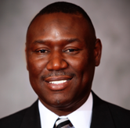
Benjamin Crump has been recognized as one of The National Trial Lawyers Top 100 Lawyers, Ebony Magazine Power 100 Most Influential African Americans, and bestowed the NAACP Thurgood Marshall Award and the SCLC Martin Luther King Servant Leader Award. In spite of his immense professional responsibilities, Benjamin Crump still finds time to serve his local community. He readily shares his professional and personal talents with local, statewide and national causes and charities.Mr. Crump was appointed as the inaugural Board Chairman of the Florida’s Big Bend Fair Housing Center, Inc., a Federal Grant organization dedicated to eradication of housing discrimination that operates on a $3,000,000.00 bi-annual budget. He also served as Board Chairman of the Legal Services of North Florida. Attorney Crump donated $1,000,000.00 to the organization’s Capital Campaign to ensure that poor people would continue to have quality legal representation and access to the courts. Attorney Crump believes in fighting to preserve the justice that minorities have achieved throughout the civil rights era and therefore served as Vice President of the National Bar Association and General Counsel to the Tallahassee Chapter of the NAACP.Mr. Crump was elected as the Board Chairman of the Internationally Renowned Tallahassee Boys Choir, and he is the Past President of the National Florida State University Black Alumni Association. Mr. Crump is a Life Member of Omega Psi Phi Fraternity, Inc., the Southern Christian Leadership Conference, and the NAACP. He is also a member of Sigma Pi Phi Boule and the Michael R. Moore Lodge 764 PHA, Free and Accepted Masons. Furthermore, Attorney Crump and his law partner Daryl Parks share their firm’s largesse with the community that has embraced them–most notably, they have endowed scholarships at Florida A&M University, Livingston College, and Florida State University for minority law students, as well as Bethune Cookman University.

Sharifa Dickinson

Arne Duncan
Arne Duncan is the ninth U.S. secretary of education. He has served in this post since his confirmation by the U.S. Senate on Jan. 20, 2009, following his nomination by President Barack Obama.
Duncan's tenure as secretary has been marked by a number of significant accomplishments on behalf of American students and teachers. He helped to secure congressional support for President Obama's investments in education, including the American Recovery and Reinvestment Act's $100 billion to fund 325,000 teaching jobs, increases in Pell grants, reform efforts such as Race to the Top and Investing in Innovation, and interventions in low-performing schools. Additionally, he has helped secure an additional $10 billion to avoid teacher layoffs; the elimination of student loan subsidies to banks; and a $500 million national competition for early learning programs. Under Duncan's leadership at the Department, the Race to the Top program has the incentives, guidance, and flexibility it needs to support reforms in states. The Department also has focused billions of dollars to transform struggling schools, prompting nearly 1,000 low-performing schools nationwide to recruit new staff, adopt new teaching methods, and add learning time. He has led new efforts to encourage labor and management to work together as never before, and their new collaboration is helping to drive reform, strengthen teaching, create better educational options, and improve learning. During Duncan's tenure, the Department has launched a comprehensive effort to transform the teaching profession.
Before becoming secretary of education, Duncan served as the chief executive officer of the Chicago Public Schools (CPS), a position he held from June 2001 through December 2008. In that time, he won praise for uniting education reformers, teachers, principals and business stakeholders behind an aggressive education reform agenda that included opening more than 100 new schools, expanding after-school and summer learning programs, closing down underperforming schools, increasing early childhood and college access, dramatically boosting the caliber of teachers, and building public-private partnerships around a variety of education initiatives. Duncan is credited with significantly raising student performance on national and state tests, increasing graduation rates and the numbers of students taking Advanced Placement courses, and boosting the total number of scholarships secured by CPS students to more than $150 million. Also during his leadership of CPS, the district was recognized for its efforts to bring top teaching talent into the city's classrooms, where the number of teachers applying for positions almost tripled.
Prior to joining the Chicago Public Schools, from 1992 to 1998, Duncan ran the nonprofit education foundation Ariel Education Initiative, which helped fund a college education for a class of inner-city children under the I Have A Dream program. He was part of a team that later started a new public elementary school built around a financial literacy curriculum, the Ariel Community Academy, which today ranks among the top elementary schools in Chicago. From 1987 to 1991, Duncan played professional basketball in Australia, where he also worked with children who were wards of the state.
Duncan graduated magna cum laude from Harvard University in 1987, after majoring in sociology.

Leeanne Dunsmore

Joan Ferrini-Mundy

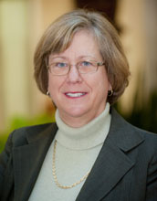
Dr. Joan Ferrini-Mundy is assistant director for the Education and Human Resources Directorate (EHR) at the National Science Foundation (NSF), a position she has held since February 2011. She serves as a member of the NSF senior management team and is involved in strategic planning and leadership for the scientific and education mission of NSF. Prior to her appointment as assistant director, she had served the foundation in a number of management capacities since 2007.
In connection with her agency-wide responsibilities, Ferrini-Mundy serves as NSF's science, technology, engineering and mathematics (STEM) workforce development goal leader for the Office of Management and Budget's Priority Goal Initiative. From 2007 through January 2010, she was a member of the National Science and Technology Council's (NSTC) Subcommittee on Education and currently serves on two task forces of the NSTC Committee on STEM Education. She is currently a member of the Mathematics Expert Group of the Programme for International Student Assessment (PISA), commissioned by the Organisation for Economic Cooperation and Development (OECD) and from 2007-2008, representing NSF, she served as an ex officio member of the president's National Mathematics Advisory Panel, and co-chaired its Instructional Practices Task Group.
Ferrini-Mundy holds an appointment at Michigan State University as a university distinguished professor of mathematics education in the departments of mathematics and teacher education. Her research interests include calculus teaching and learning, mathematics teacher learning and mathematics and science education policy at the K-12 level. Ferrini-Mundy holds a Ph.D. in mathematics education from the University of New Hampshire.

Diane J. Frasier
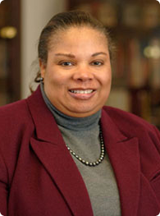
Ms. Diane Frasier currently serves as the Director, Office of Acquisition and Logistics Management and the Head of the Contracting Activity at the National Institutes of Health. Ms. Frasier oversees all of the NIH’s acquisition, property, supply and transportation programs. During her tenure at the NIH, Ms. Frasier initiated the design, development and implementation of the NIH Contractor Performance System – one of the first systems to collect and retrieve contractor past performance information. Ms. Frasier also chaired the joint agency committee which established the Federal Past Performance Retrieval System, PPIRs. Working closely with the NIH’s 27 Institutes and Centers (ICs), Ms. Frasier oversaw the restructuring of the NIH’s 18 contracting offices to 10 offices while ensuring continued acquisition service to the ICs. Ms. Frasier also played a critical role in the transition from a legacy management system to the NIH’s New Business System and its reporting system, nVision. Ms. Frasier continues to be an avid supporter of acquisition streamlining as evidenced by the management of the NIH’s Information Technology Acquisition and Assessment Center (NITAAC), a Government-wide Acquisition Contract. Prior to joining NIH, Ms. Frasier had a long career with the Department of Defense.
Ms. Frasier began her federal career as a Presidential Management Intern. Ms. Frasier holds a BA from the University of Virginia and MPA from the C.W. Post Center of Long Island University. Ms. Frasier is a 1993 graduate of the Industrial College of Armed Forces and a 1994 graduate of Harvard University’s Senior Officials in National Security. Ms. Frasier is a CPCM, NCMA fellow and a member of NCMA’s Board of Advisors. Ms. Frasier is the recipient of numerous awards including the 2009 Presidential Rank Award – Meritorious Executive.

Wayne A. I. Frederick

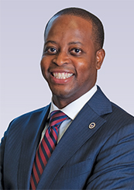
Wayne A. I. Frederick, M.D., M.B.A., FACS was elected 17th President of Howard University in July 2014. He recently launched Howard’s Center for Academic Excellence, a center created specifically and wholly to provide student retention support services to increase undergraduate success. He also introduced the Graduation & Retention Access for Continued Excellence (GRACE) grant program, which provides need-based funding, designed to reduce financial barriers and increase on-time graduation.
He earned a Bachelor of Science degree, a Doctor of Medicine, and completed his surgical residency training at Howard University Hospital. After fulfilling his post-doctoral research and surgical oncology fellowships at the University of Texas MD Anderson Cancer Center, Dr. Frederick began his academic career as Associate Director of the Cancer Center at University of Connecticut, where he also served on the Department of Surgery faculty.
Since returning to Howard University in 2006, Dr. Frederick has served as Interim President, Provost & Chief Academic Officer, Associate Dean in the College of Medicine, Division Chief in the Department of Surgery, Director of the Cancer Center, and Deputy Provost for Health Sciences and he also earned a Master of Business Administration.
As a distinguished researcher and surgeon, Dr. Frederick is the author of numerous peer-reviewed articles, book chapters, abstracts, and editorials. He has also received numerous awards honoring his outstanding scholarship and service. In June 2014, Congress recognized him for his contributions in addressing health disparities among African-Americans and historically underrepresented groups.

George T. French

Dr. George French currently serves as the 14th President of Miles College, after serving as a member of the President’s Cabinet in the capacity of Director of Institutional Planning and Development. As Director of Development, Dr. French helped lead the largest Capital Campaign Fund Drive in the history of Miles College to that date, placing the College on sound financial footing. During his tenure as President, Dr. French was appointed by the United States Congress to serve on the National Advisory Committee on Institutional Quality and Integrity. He has won numerous awards to include Birmingham Spotlight “Man of the Year” award and also serves as a member of the Regions Financial Diversity Advisory Council. Dr. French earned his Bachelor’s degree from the University of Louisville. He earned his Juris Doctorate from Miles Law School and his Ph.D. from Jackson State University.

Athena Fulay

Juan Gilbert
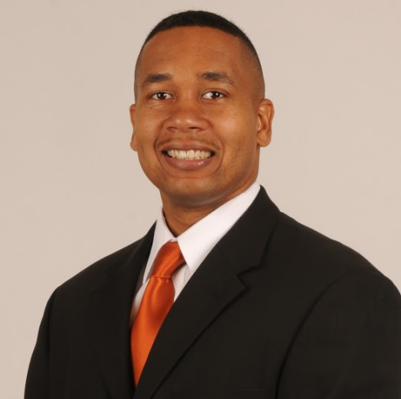
Dr. Juan E. Gilbert is an American computer scientist, researcher, inventor, and educator. A staunch advocate of diversity in the computing sciences, Gilbert's successful efforts to increase the number of underrepresented minorities in the computing disciplines have been recognized by professional engineering organizations and the United States government. In honor of both his accomplishments and his service to the university, Gilbert was awarded the first Presidential Endowed Chair at Clemson University on November 9, 2012. As a result of Dr. Gilbert's efforts, in 2012, Clemson was home to 10% of the African American computer science professors, and 10% of the African American computer science doctoral students in the United States. In 2014, Dr. Gilbert left Clemson University and joined the Computer & Information Science & Engineering Department at the University of Florida where he serves as the Andrew Banks Family Preeminence Endowed Chair and the Associate Chair of Research.

Chanelle Hardy
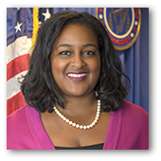
Chanelle Hardy serves as Chief of Staff to the Commissioner and Media Legal Advisor. Ms. Hardy joined the Commission in May 2015 following a five-year stint as Senior Vice President for Policy and Washington Bureau Executive Director for the National Urban League, a 104-year old civil rights and direct services organization focusing on economic empowerment and social justice for communities of color and low-income Americans. Prior to that, Ms. Hardy served as a Counsel and Chief of Staff to US Congressman Artur Davis, as a Staff Attorney for the Federal Trade Commission Enforcement Bureau, as a Fellow and Legislative Counsel for Consumers Union, and as a fifth-grade teacher for Washington, DC Public Schools (Teach for America Corps). Ms. Hardy holds a J.D. from the Howard University School of Law.

LaDoris “Dot” Harris

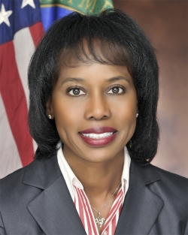
The Honorable La Doris “Dot” Harris brings over 30 years of leadership and management experience as the Director of the Office of Economic Impact and Diversity at the U.S. Department of Energy (DOE). She ensures that minorities and historically underrepresented communities are afforded opportunities to actively participate in the Department’s programs.
Nominated by President Barack Obama and confirmed by the U.S. Senate on March 29, 2012, Director Harris serves in an Assistant Secretary level position at the Department of Energy. She leads the agency’s offices of Minority Economic Impact, Minority Education and Community Development, Minority Business and Economic Development, Diversity and Inclusion, and Civil Rights. Additionally, Director Harris spearheads the DOE’s Minorities in Energy Initiative; serves on the White House Council on Women and Girls; oversees the corporate funding strategy for minority institutions; develops and implements minority business contracting opportunities; and advocates and protects the civil rights of employees and recipients of multi-billion dollar funding vehicles from the DOE.
Through publications and community outreach, she has reached over 80 million people on the topic of diversity, economic development, and sustainability in the STEM workforce.
Director Harris recently received the 2014 Diversity Journal “Women Worth Watching” Award; the 2014 EmpowHer Institute PathMaker Award; the 2014 Fort Valley State University Platinum Achievement Award; and the 2013 Black Business Association Chairperson’s Award. She was, also, highlighted in Essence Magazine's 2014 editorial feature, ‘Game Changers: The Power List’.
Prior to her appointment, Director Harris was Co-founder, President and CEO of Jabo Industries, LLC, a successful minority-woman owned engineering management consulting firm concentrated primarily in the energy, information technology, logistics, and healthcare industries. She served as an executive at General Electric Company (GE) and held a number of leadership positions in GE's Energy and Industrial Systems businesses. Before joining GE, Director Harris was the first African American female officer, Vice President of Operations & Production at ABB, Inc., the world’s largest electrical engineering firm. She, also, spent twelve years as a Field Services Engineer and Services Manager with Westinghouse Electric Company where she was the named youngest manager in the history of the Nuclear Services Division of Westinghouse.

Director Harris holds a B.S. in Electrical Engineering from the University of South Carolina and a M.S. in Technology Management from Southern Polytechnic State University. She was granted an Honorary Doctorate of Humane Letters from Chicago State University and a Doctor of Laws Degree Honoris CAUSA from Clark Atlanta University.

William R. Harvey

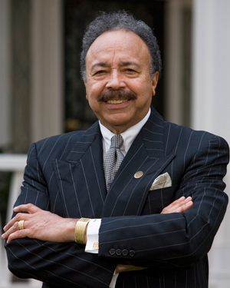
Dr. William R. Harvey is President of Hampton University and 100% owner of the Pepsi Cola Bottling Company of Houghton, Michigan. Since 1978, he has served with distinction as President of Hampton University and created a monumental legacy during his thirty year tenure – one of the longest tenures of any sitting president of a college in the country. After graduating from Talladega College, Dr. Harvey served three years on active duty with the United States Army. He is currently a Lieutenant Colonel in the Army Reserve. Dr. Harvey earned his doctorate in College Administration from Harvard University. Prior to his current position, he served as Assistant for Governmental Affairs to the Dean of the Graduate School of Education at Harvard University; Administrative Assistant to the President at Fisk University; and as Administrative Vice President at Tuskegee University.

Ben Hasan

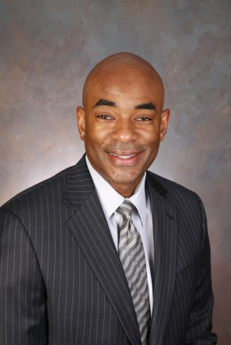
Ben Hasan joined the Global People team as Chief Culture, Diversity and Inclusion Officer in 2015. In this global role Ben and his team are responsible for the continued development of the heathy evolution of the company’s culture, the development of behaviors that embrace diversity at all levels of the company and the promotion of the company’s external reputation as a great place top work.

Ben Hasan joined Walmart in 2008, and previously served as senior vice president Strategic Services in Walmart Technology. In this role he and his team were responsible for ISD Strategy, Communication, Innovation, ISD Vendor Management, Project Management Office, Business Analysis, GTS – India & Mexico and Quality Assurance.

Prior to his current role at Walmart, Ben worked 11 years at Dell Inc. He progressed through several leadership positions before serving as vice president of Corporate and Product Group I/T. In this position, he directed teams in Texas, Shanghai, Taipei, and Singapore. He also served as general manager of Dell’s I/T development centers in Brazil and India. Before joining Dell, he gained broad experience in I/T, Human Resources, Rates and Regulatory Affairs, and Customer Service during his 14-year career with ENSERCH Corporation, an oil and gas company based in Dallas, Texas.

In 2006, Ben received the Temple University Fox School I/T Award for Distinguished Alumni.
Ben holds an M.B.A. from Amber University in Dallas, Texas, and a bachelor’s degree in business administration with a concentration in computer science from Temple University in Philadelphia.

Brian O. Hemphill

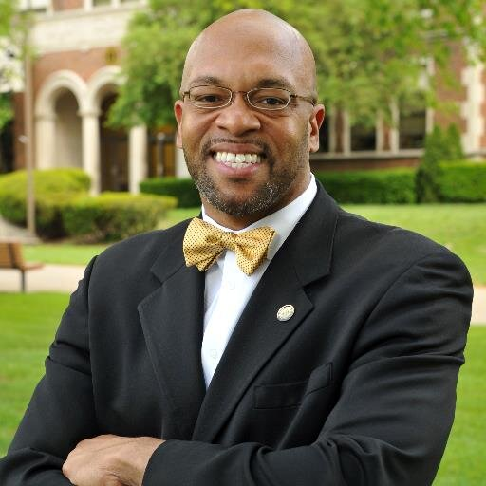
Dr. Brian Hemphill currently serves as the 10th president of West Virginia State University, joining in July 2012. Prior to this role, Dr. Hemphill served as Vice President for Student Affairs and Enrollment Management at Northern Illinois University. Dr. Hemphill also served as a member of the Board of Trustees in St. Augustine’s College in North Carolina, his alma mater. Currently he serves on the Charleston Area Alliance Board of Directors, the Thomas Health System Board of Trustees, and the West Virginia Roundtable Board of Directors. Dr. Hemphill earned a Ph.D. in Higher Education Administration from the University of Iowa, a Master of Science degree in Journalism and Mass Communication from Iowa State University of Science and Technology.

Damien Hooper-Campbell

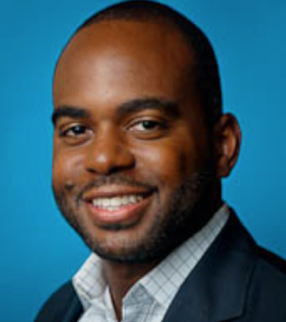
Damien Hooper-Campbell is a Global Diversity & Inclusion Lead at UBER. Prior to this roll, he served as a Diversity Strategist within Google's Diversity, Integrity & Governance team.
Prior to becoming a Googler, Damien was a Vice President within Goldman Sachs’ Pine Street Leadership Development Group in NYC. Prior to Goldman, Damien was an Assistant Director on the Harvard Business School (HBS) Admissions Board in Boston, where he led strategy and marketing for the 2+2 Program and co-led underrepresented minority outreach initiatives.
Before attending HBS, he served the Harlem, NYC community as an Associate Program Officer in the Non-Profit Investments arm of the Upper Manhattan Empowerment Zone Development Corporation (UMEZ) during the day while managing a local Chinese, organic food restaurant in the evenings. Before UMEZ, Damien was an Analyst in Morgan Stanley’s Investment Banking Division covering global consumer and retail clients.
He earned his BA in Economics from Morehouse College and his MBA from Harvard Business School. Damien served as a Mentor within Morehouse’s Executive Mentorship Program and recently completed a two-year term on the board of non-profit, New Jersey Needs You (NJNY).
Rick Hughes

Rick Hughes began his career in the US Army, attending Airborne School and Ranger School, and serving in the US and abroad. After six years of active duty, Rick remained with the US Army Reserves until 1991, attaining the rank of Major. In 1982, Rick began his career with P&G as a Purchasing Manager for the company’s Baby Care and Feminine Care businesses. He then served in a variety of roles in Purchasing and in a Customer Business Development role over his 31+ years. Rick is now advising C-Suite executives on how to grow their business, transform their supply chains and obtain greater value from their external supply base. He is also a speaker on a variety of topics, like leadership, strategy development and execution, talent enhancement, supply innovation and risk management. He is also the Chairman of the Billion Dollar Roundtable. He is working with GEP Consulting in an advisory role to help grow and develop their procurement consulting business. Rick is a graduate of The University of Notre Dame and also holds an MBA from the Florida Institute of Technology and a Juris Doctorate from Salmon P. Chase College of Law.

Reginald E. Humphrey

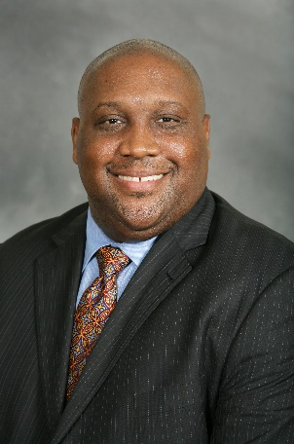
Reggie Humphrey is the Senior Manager of Supplier Diversity at General Motors and joined the team in July 2012. He is responsible for managing GM’s supplier diversity process of inclusion, Reggie began his career journey in 1995 as a Production Supervisor at the Moraine Assembly Center in Moraine, OH. In 1998, he relocated to the Detroit metro area and has since worked in several operational and planning capacities in multiple organizations. In addition to Reggie’s core responsibilities, he serves as a voluntary board member for several organizations including the Real Life 101 Scholarship & Mentoring Foundation, Michigan Minority Supplier Development Council (MMSDC), Great Lakes Women’s Business Council, WBE Canada, and the Canadian Aboriginal and Minority Supplier Council (CAMSC). Reggie also serves as a member of the NMSDC Supplier Diversity Advisory Council, Global Links Council, and the President of the Automotive Industry Group (2014/15). Reggie was recently awarded the National Advocate of the Year by the Michigan Minority Supplier Development Council in October 2014 and a Global Community Service Award from the Ajamu Group in January 2015. Reggie holds a B.S. in Finance from Alabama A&M University and a M.S.A. from Central Michigan University.

Melissa Ingram

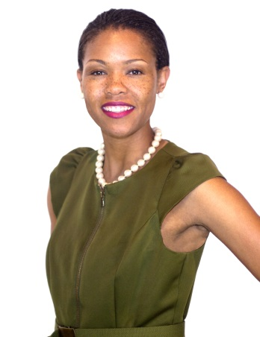
As one of the most senior team members of ASPiRE, Melissa M. Ingram, oversees the business and legal affairs department for the network and is responsible for developing new business opportunities and partnerships to support company initiatives. In her role as Senior Director, Ingram has developed partnerships with the White House Initiative on Educational Excellence for African Americans (WHIEEAAs), the White House Initiative on Historically Black Colleges and Universities (WHI-HBCUs) and solidified an unprecedented partnership with the Southern Intercollegiate Athletic Conference (SIAC) and its member schools to develop programming, highlighting the rich legacy and history of HBCUs and their product – the students. Ingram also successfully oversaw the process of ASPiRE becoming the first and only national cable television network to receive its certification as a Minority Business Enterprise (MBE)and serves as the network’s liaison with the Georgia Minority Supplier Development Council (GMSDC).In 2013, Ingram was selected as one of Multichannel News’ 40 under 40 young industry executives.

Ingram joined ASPiRE from UP TV, where she was Senior Counsel of Business and Legal Affairs, serving as lead counsel and negotiator for programming acquisition agreements. While at UP TV in 2011, Ingram was awarded a scholarship from the Walter Kaitz Foundation and was nominated and selected to attend the Women in Cable Telecommunications (WICT) Rising Leaders Program in San Diego, California.

efore joining UP TV in 2008, Ingram was an associate lawyer with an Atlanta-based boutique entertainment firm, The Carter Law Firm, PC where she handled various entertainment contracts. She began her career in 2004 as an associate lawyer in the Labor and Employment group with one of the largest Southeast law firms, Alston & Bird, LLP in Atlanta, Georgia.

Ingram earned a Juris Doctorate (J.D) from the University of California, Berkeley (Boalt Hall) School of Law and a Bachelor of Arts Degree in English, magna cum laude, from Spelman College in Atlanta, Georgia. Ingram currently sits on the Southeast Board of Directors for WICT as a Director at Large and is a member of one of the nation’s oldest volunteer service organizations, The Links, Incorporated.

Rinaldi Jacobs, Sr.

Rinaldi Eugene Jacobs Sr. has been called a “Serial Entrepreneur.” Current, Jacobs is the head of a diverse array of businesses. Full Circle Development, LLC is his real estate development business. FCD has allowed him to journey into other business ventures such as construction and demolition, recycling, and commercial loan brokering.
Jacobs holds a Bachelor of Arts in Political Science and a Master of Arts in Media and Communication, both from Southern University. While at Southern, Jacobs embraced the ideals of Community Capitalism. According to him, it is a simple value system that calls for investment in the community in which you live, but not totally dependent upon outside capital to fund your dreams.
Jacobs is currently pursuing the dreams he has held for a life time: the redevelopment of blocks of properties around his beloved Southern University and in the neighborhoods of North Baton Rouge. “Every city has its dividing lines. In Baton Rouge, LA it is a street call Florida Blvd which cuts the city in half literally.” His many years as a mortgage banker with Wells Fargo, Liberty Bank, National City Bank and owning his own brokerage firm has given me a keen insight into the ways deal are financed and structured. Additionally, the knowledge gained through the use of his Political Science degree and years of running political campaigns, along with working in government in numerous capacities allow Jacobs to quickly navigate the many regulatory processes which are a part of real estate development. “I don’t look at it simply as real estate development: it is neighborhood redevelopment in most cases” he stated.
In addition to Full Circle Development, Jacobs plans to launch Full Circle Construction in October of 2015. Jacobs is also heading up Full Circle Freight, his foray into the dynamic trucking and transportation business. Always one seeking to take advantage of each opportunity presented, Jacobs is involved in the marine services with Brother Earth Marine Services, with Caribbean partners.
Jacobs lives in Baton Rouge with his wife, Belinda, whom he met at Southern University. They have two sons, both of whom are working with the family enterprises.

Anneka Jenkins

Anneka Jenkins was born and raised in Kansas City, MO. Graduating from the University of Missouri - Kansas City in 2004, this member of Kappa Alpha Sorority, Inc. [Rho Alpha Chapter Fall 2003] and Alumni NFL Cheerleader received her degree in Communications with an emphasis in TV and Radio Broadcasting.

Upon receiving her degree, Anneka worked as the Sales Coordinator at CBS Radio in Kansas City. Open to accepting a change in environment, Anneka moved to Atlanta where she held the Local Sales Coordinator position for Radio One and Special Events/Sales Coordinator for such events as Hot 107.9's Birthday Bash, Praise 102.5's Praise in the Park, CoCo Brother's Stand, Co Co Brother's One Night Stand and many more!

Anneka currently lends her Consumer, Social + Digital marketing skills to the television network owned by Earvin "Magic" Johnson, ASPiRE.

Not limiting her skills to media, Anneka also finds time for philanthropy. She is the the Co-Founder of Show Me Shoes Foundation, an independent non-profit organization established in 2009 to assist young girls who may have experienced unexpected hardships and are in need. Show Me Shoes Foundation takes the donations of new and lightly worn women dress and
casual shoes. Our intent is to give back to women by rebuilding confidence… starting at the "sole".

David J. Johns

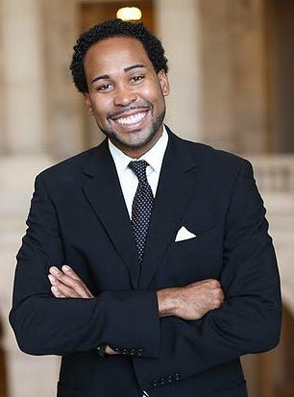
David J. Johns is the executive director of the White House Initiative on Educational Excellence for African Americans. The Initiative works across federal agencies and with partners and communities nationwide to produce a more effective continuum of education programs for African American students. Prior to joining the Department of Education, Johns was a senior education policy advisor to the Senate Committee on Health, Education, Labor and Pensions (HELP) under the leadership of Sen. Tom Harkin, D-Iowa. Before working for the Senate HELP committee, under Chairman Harkin, Johns served under the leadership of the late Sen. Ted Kennedy, D-Mass. Johns has worked on issues affecting low-income and minority students, neglected youth and early childhood education and with Historically Black Colleges and Universities. His research as an Andrew W. Mellon Fellow served as a catalyst to identify, disrupt, and supplant negative perceptions of Black males within academia and society. Johns is committed to volunteer services and maintains an active commitment to improve literacy among adolescent minority males. Johns obtained a master’s degree in sociology and education policy at Teachers College, Columbia University, where he graduated while simultaneously teaching elementary school in New York City. He graduate with honors from Columbia University in 2004 with a triple major in English, creative writing and African American studies.

Brian Johnson

Dr. Brian Johnson is the 7th President of Tuskegee University.Dr. Johnson is an accomplished professor, scholar and administrator who has published (7) academic and scholarly books–including (2) books on William Edward Burghardt Du Bois and (1) institutional history of his alma mater-Johnson C. Smith University, a historically black university. Dr. Johnson received his Ph.D. in English from the University of South Carolina specializing in 17th-19th Century American Literature and his M.A. in English from The University of Wisconsin-Madison.
Among several academic and administrative awards, he has received a (2012-2013) (A.C.E.) American Council of Education Fellowship (Presidential Aspirant), a (2012-2013) (A.A.S.C.U.) American Association of State College and University Millennium Leadership Initiative Fellowship (Presidential Aspirant), a (2011-2012) (CCCU) Consortium of Christian Colleges and Universities rising senior administrative Fellowship, a (2011-2012) Tennessee Board of Regents Maxine Smith rising senior administrator Fellowship at the Tennessee Higher Education Commission, a (2007) Woodrow Wilson/Career Enhancement Sabbatical Fellowship, a (2006-2007) appointment as the Civic Engagement Scholar within the (J. McDonald Williams Institute-Dallas, Texas), a (2005-2007) Lilly Foundation/Center for Christian Studies Fellowship (Gordon College, Wenham, MA), a (2004-2005) non-resident fellowship within the W.E.B. Du Bois Institute for African and African American Studies (Harvard University) and a (2003-Present) Andrew W. Mellon-Benjamin Mays Postdoctoral Fellowship.

Lonnie G. Johnson

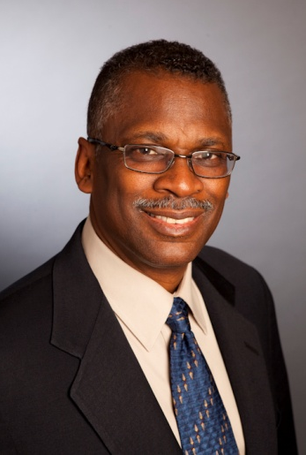
Lonnie G. Johnson is president and founder of Johnson Research and Development Co., Inc., a technology development company. Mr. Johnson holds a Mechanical Engineering degree from Tuskegee University. Upon graduating, Mr. Johnson worked as a research engineer at Oak Ridge National Laboratory and then joined the U.S. Air Force as Acting Chief of the Space Nuclear Power Safety Section. In 1989, Mr. Johnson formed his own engineering firm and licensed his most famous invention, the Super Soaker water gun. Two years later, the Super Soaker generated over $200 million in retail sales, and became the number one selling toy in America. Currently Mr. Johnson holds over 80 patents and is the author of several publications on spacecraft power systems.

Ryan Kelsey

Ryan Kelsey is a Program Officer for the Education Program at the Helmsley Charitable Trust where he primarily focuses on national work in undergraduate STEM education. He also contributes to the K-12 program in the area of teacher preparation and on effective uses of educational technology.
Prior to coming to the Trust, Ryan spent 13 years at the Columbia University Center for New Media Teaching and Learning, most recently as the Director of Projects. At Columbia, Ryan led a team of educational technologists and design specialists partnering with faculty on innovative educational projects in the full range of academic disciplines, including simulations, case studies, health interventions and global learning initiatives with funding from multiple public and private sources. He has also served as an adjunct assistant professor and instructor at Teachers College and New York University, offering courses in the design and analysis of effective solutions for improving higher education classroom practice using purposeful technology.
Ryan earned his Ed.D. and M.A. in Communication and Education from Teachers College and his B.S. in biology from Santa Clara University. He also devotes time to environmental issues by serving on the board of the Black Rock Forest Consortium.

Julie Kirk

Julie Kirk currently serves as the Director of the Office of Innovation and Entrepreneurship (OIE), within the U.S. Department of Commerce after being appointed by U.S. Secretary of Commerce Penny Pritzker. In her capacity as Director of OIE, she is charged with driving programs and policies that support innovative economic development. Prior to her appoints, Ms. Kirk served as the Executive Director for the Maryland Center for Entrepreneurship, an initiative of the Howard County Economic Development Authority. In 2010, Ms. Kirk co-founded the Path Forward Center for Innovation and Entrepreneurship as a nonprofit that develops and delivers innovative programs to expand economic opportunities for women through entrepreneurship.

Douglas Kramer

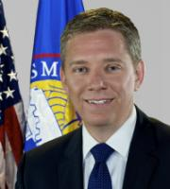
Douglas J. Kramer was confirmed as Deputy Administrator of the U.S. Small Business Administration (SBA) on June 11, 2015. In this capacity, he is responsible for managing the agency and ensuring the efficient operation of its programs. He works to make sure the Agency fulfills its promise to support U.S. Small Businesses.
Prior to this role, he was Counselor to SBA Administrator Maria Contreras-Sweet, where he advised on day-to-day management operations of the SBA and the agency’s efforts to support the growth and success of American small businesses.
Before joining the SBA, Mr. Kramer served in numerous senior leadership positions within the Obama Administration. From November to March 2015, he was General Counsel of the United States Agency for International Development (USAID) -- an agency with more than 9,600 employees, operations in over 100 countries, and an annual budget of $20 billion. In this role, he managed a team of more than 100 lawyers and was charged with ensuring compliance with extensive regulatory and statutory guidelines, while also advising USAID leadership on legal matters and providing recommendations on policy creation.
For more than four years, Mr. Kramer held a number of leadership positions at the White House. From March 2012 to November 2013, Mr. Kramer worked as Deputy Assistant to the President and White House Staff Secretary. From 2009 to 2012, he served in the Office of the White House Counsel, first as Deputy Associate Counsel for Presidential Personnel, and then as Special Assistant to the President and Associate Counsel to the President.
Prior to joining the White House, Mr. Kramer served as Counsel in the Antitrust Division at the Department of Justice. From 2006 to 2009, he worked as an Associate and then Shareholder at the law firm Polsinelli PC. From 2001 to 2006, he was an Associate at the law firm Covington & Burling. Earlier, Mr. Kramer served as a Judicial Clerk in the Chambers of the Hon. Walter L. Carpeneti of the Alaska Supreme Court.
A Kansas native, Mr. Kramer received a B.A. from Georgetown University and a J.D. from the University of Chicago Law School.

Courtney Lamar

Reginald K. Layton

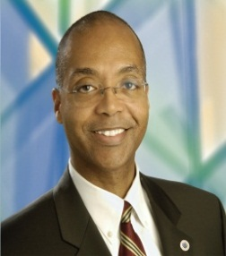
Reginald K. Layton is the Vice President of Supplier Diversity and Supply Chain Sustainability at Johnson Controls, Inc. In this position, he is responsible for overseeing all diverse purchasing activities of Johnson Controls company-wide. The company’s achievements have garnered prestigious recognition, as Johnson Controls was named Corporation of the Year and Mr. Layton was named Minority Business Enterprise Advocate of the Year by the National Minority Supplier Development Council in 2003. Recently, Mr. Layton has been honored as Minority Supplier Development 2013 Leader of the Year. Mr. Layton received his Bachelor’s Degree and a Master’s Degree from Case Western Reserve University. Mr. Layton also serves on the advisory board for the Tuck School’s Minority Business Executive Program at Dartmouth College.

Lisa Lee

Lisa Lee leads diversity initiatives at Pandora and is a self-proclaimed diversity geek who spends 90% of her time thinking about a more equitable society through tech. She is a frequent speaker on topics related to diversity in tech and has been featured at SXSW, on NPR, and in Al Jazeera. Prior to Pandora, Lisa started her career in tech as one of the early employees at Facebook. During her seven years there, she led initiatives in user operations, product operations, and diversity. Passionate about Asian American issues, Lisa founded and chaired the Facebook AAPI Employee Resource Group, is formerly the publisher of Hyphen magazine, and cofounded positive body image site ThickDumplingSkin.com. Lisa graduated from UC Berkeley in Mass Communications and Theatre & Performance Studies. She also serves on the board of Asian Americans for Civil Rights and Equality. You can follow her at @rrrlisarrr and at misslisalee.com.

Torian Lee

Joe Leonard

David Levin

David Levin is Senior Program Manager in the Department of State’s Bureau of Educational and Cultural Affairs, where he coordinates Fulbright scholar programs and other academic exchanges worldwide. He also coordinates the Bureau’s diversity-related activities and does much of the Bureau’s outreach efforts throughout the United States particularly to colleges and universities, including minority serving institutions, community colleges, and others. Finally he serves as a speechwriter and special projects officer for the Assistant Secretary for Educational and Cultural affairs and other Department of State senior officers.
Prior to his current position, Levin spent fifteen years with the former U.S. Information Agency and seven years with the Department of Education, managing a wide range of international education programs and activities. Before joining the Federal Government, he served as a Special Assistant to the Director of the International Division of the American Council on Education. Levin holds a B.A. in Government from Beloit College and a Master’s degree in Public Administration in International Affairs from American University. He has studied, worked and traveled throughout the United States, Europe, Asia, the Middle East and North Africa.

Gayle Lomax

Tizoc S. Loza

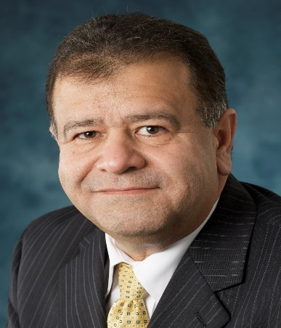
Tizoc S. Loza is the Corporate Manager, Global Supplier Diversity Programs/ Government Relations for Northrop Grumman Corporation. His responsibilities include direction and management, as well as corporate-wide oversight, of the Mentor-Protégé, Small Business Innovation Research (SBIR), AbilityOne and Historically Black Colleges and Universities/Hispanic Serving Institutions/Tribal colleges and Universities (HBCU/HIS/TCU’s) Programs. Mr. Loza is responsible for the review and implementation of corporate strategies concerning small business initiatives. He also works with the sectors to implement processes that enable each sector to collaborate and develop partnerships with small businesses that have innovative technologies which can be incorporated into government platforms. Mr. Loza has over twenty eight years of experience in the Aerospace Industry incorporating diverse assignments such as marketing, procurement, contracts manager, and small business liaison officer. He received his Bachelor’s Degree in Financial Management and International Business from California State University in Long Beach, and obtained an MBA with emphasis in Supply Chain from Strayer University. Mr. Loza also has a Government Contract Management and Business Programs Certification from the University of California and is a certified Six Sigma Green Belt.

Jacquelyn Madry-Taylor

Pamela J. Maimer

Emily Mann

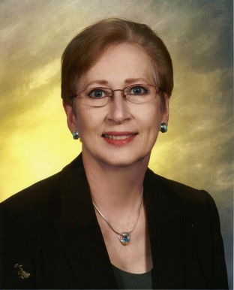
Emily Mann supports the Lockheed Martin Enterprise Operations business unit in their Supplier Diversity program, recruiting small businesses with niche capabilities, and helping suppliers understand how to market their services to Lockheed Martin. She is part of the Global Supply Chain Operations procurement group where she works with buyers and subcontract managers in identifying suppliers who can meet the full scope of needs. In her role with Lockheed Martin, Ms. Mann travels to locations across the United States meeting with suppliers and helping them evaluate and pursue opportunities. Ms. Mann has been with Lockheed Martin and Martin Marietta since 1980, and has a diverse background in information technology, requirements planning, procurement, subcontract management, and business. Ms. Mann received both her Bachelors degree and Masters degree in Business Administration from Regis University. She is certified as Green Belt in the Lockheed Martin Operating Excellence combined disciplines of Lean and Six Sigma. She is certified as a Supplier Diversity Professional by the Alliance of Supplier Diversity Professionals (ASDP).

Harold Martin

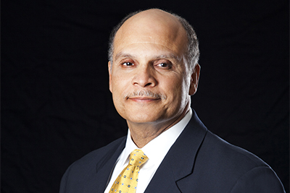
Harold L. Martin Sr. is the first alumnus to serve as the chief administrator at North Carolina Agricultural and Technical State University. As the 12th chancellor, Martin provides visionary leadership that establishes long range strategic plans in consultation with various constituencies, asserts tactical leadership to develop innovative approaches for expansion resources, and ensures the fiscal and academic vitality of all colleges and schools. Prior to his appointment as chancellors, Dr. Martin was the senior vice president for academic affairs at The University of North Carolina, General Administration. In this capacity, he advised the president and the UNC Board of Governors. Before joining UNC General Administration, Dr. Martin was the chief administrator and chancellor of Winston-Salem State University. At WSSU, he guided the reclassification of the university from a Baccalaureate I to a Master’s II institute, created a School of Graduate Studies and Research, and established seven master’s degree programs. As a Winston-Salem native, Dr. Martin received his Bachelor’s and Master’s degrees from North Carolina Agricultural and Technical State University and his Ph.D. from Virginia Polytechnic Institute and State University.

Zola Mashariki

Zola Mashariki is currently Executive Vice President, Head of Original Programming at BET Networks in Los Angeles, CA, where she oversees original programming for both BET and CENTRIC Networks. Prior to BET Networks, Zola spent 15 years at Fox Searchlight, where she began in May 2000 as a production intern and became Senior Vice President in 2008. Born and raised in Brooklyn, NY, Ms. Mashariki is a graduate of Dartmouth College and Harvard Law School. During her tenure at Harvard, she worked as a research assistant to the late Judge A. Leon Higginbotham and was a Teaching Fellow at Harvard College and Harvard Law School with Professors Cornel West and Roberto Unger. After law school, Zola practiced corporate law at Proskauer Rose LLP in New York and Manatt, Phelps and Phillips LLP in Los Angeles, focusing on mergers and acquisitions and secured transactions. She also worked with the late playwright August Wilson and co-founded the African Grove Institute for the Arts (AGIA), the first national black theatre organization. Among her many honors, Ms. Mashariki was included in The Hollywood Reporter’s prestigious “Next Gen” list, as well as Black Enterprise’s “40 under 40”: Next Generation of Women of Power. She has been recognized by the National Association of Black Female Executives in Media & Entertainment with the “Dreamgirl Award." Essence magazine listed her as one of the most powerful African-Americans in Hollywood. In 2012, she was featured in The Dartmouth magazine's five part series profiling successful alumni. Later that year, she was honored by the Black Women Lawyers Association and recipient of their Leadership Award. Most recently, she received the Delta Sigma Theta “Impact” award, the 2014 Special Achievement award from the African-American Film Critics Association, the 2014 Mosaic Woman Trailblazer award and was part of Ebony magazine’s 2014 “Power 100” list.

Travis Mason

Willie E. May

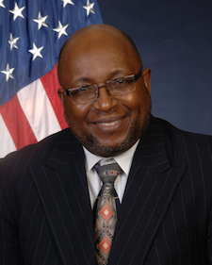
On May 4, 2015, Congress confirmed Dr. Willie E. May as the 15th Director of the National Institute of Standards and Technology (NIST). He also serves as Under Secretary of Commerce for Standards and Technology, a position created in the America COMPETES Reauthorization Act of 2010. Dr. May had served as Acting NIST Director and Acting Under Secretary of Commerce for Standards and Technology since June 2014. Prior to that assignment, he was Associate Director for Laboratory Programs, where he was responsible for oversight and direction of NIST's seven laboratory programs and served as the principal deputy to the NIST Director.

As NIST Director, Dr. May provides high-level oversight and direction for NIST. The agency promotes U.S. innovation and industrial competitiveness by advancing measurement science, standards, and technology. NIST's FY 2015 resources total $863.9 million in direct appropriations, an estimated $50 million in service fees, and $120 million services rendered to other agencies on a cost reimbursable basis. NIST employs about 3,000 scientists, engineers, technicians, support staff, and administrative personnel at two main locations in Gaithersburg, MD, and Boulder, CO. NIST also hosts ~3500 Associates from academia, industry, and other government agencies, who collaborate with NIST staff and access user facilities. In addition, NIST partners with more than 1,300 manufacturing specialists and staff at more than 400 MEP service locations around the country.
Dr. May led NIST's research and measurement service programs in chemistry-related areas for more than 20 years. His personal research activities were focused in the areas of trace organic analytical chemistry and physico-chemical properties of organic compounds, where his work is described in more than 85-archival publications.
Dr. May has several leadership responsibilities in addition to those at NIST. He is Vice President of the 18-person International Committee on Weights and Measures (CIPM), President of the CIPM’s Consultative Committee on Metrology in Chemistry and Biology; Executive Board Member for the Joint Committee on Traceability in Laboratory Medicine; External Advisory Boards for the UK National Physical Laboratory and Japan’s National Institute of Advanced Industrial Science and Technology.

A few of Dr. May’s accomplishments and awards include: Alumnus of the Year Award from the College of Chemical and Life Sciences at the University of Maryland, 2007; Member of first class of inductees into the Knoxville College Alumni Hall of Fame, 2010; Fellow of the American Chemical Society, 2011; Honorary Doctor of Science and Speaker at Graduate School of Arts and Sciences Commencement Exercises, Wake Forest University, 2012.

Derek McGowan

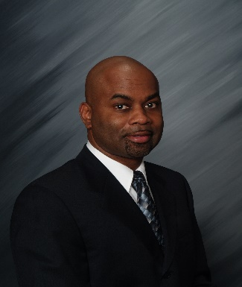
Derek McGowan has been with Lockheed Martin since 2001, where he is the Program Manager for STEM, Generations, and Higher Education within the Corporation’s Diversity and Inclusion team. Primary responsibilities include driving the implementation of diversity and inclusion efforts in STEM programs, relationship building, student development and recruiting at Historically Black Colleges and Minority Serving Institutions (HBCUs and MSIs). Prior to his current role Derek was the LM Campus Relations Manager. He and his team managed a multi-million dollar budget that directly impacted branding and recruiting for the multi-billion dollar Corporation. He supported LM commitments to campuses, student organizations that impacted recruiting efforts at both regional and national levels. Mr. McGowan has worked in the recruiting profession for more than 27 years which includes seventeen years of diverse Air Force recruiting experience. He received an undergraduate degree from St. Leo University and has two classes to complete a dual Master’s degree in HR Management and Training and Development from Webster University.

Stacy Milner

Stacy Milner is an entertainment industry veteran who has served as the executive assistant to the chairmen of NBC and Paramount Pictures. She is the Founder of Executive Temps, one of the premiere employment agencies exclusively serving the entertainment industry for over 25 years. Milner’s began her career as an NBC Page prior to assisting the late Brandon Tartikof. She also served as the executive assistant to Warren Littlefield, former NBC Entertainment President while serving in a dual capacity as the west coast executive assistant to former Chairman, Robert Wright. After leaving NBC, Milner joined Paramount Pictures as the executive assistant to former TV Group Chairman, Kerry McCluggage. Her latest venture, the Entertainment Industry College Outreach Program, is designed to meet the industry’s need and desire to educate, recruit and develop a culturally and ethnically diverse workforce. This innovative pipeline development program brings some of the world’s leading media, entertainment and communication companies to the campuses of Historically Black Colleges & Universities, Hispanic Serving Intuitions as well as diverse student groups on college and university campuses across the country. The success of the program has garnered the attention and support of the White House Initiative on Historically Black Colleges & Universities (WHI-HBCU). Stacy is an entrepreneur and a highly sought-after professional speaker, lecturer, career strategist and leader in the entertainment and staffing industries.

James T. Minor
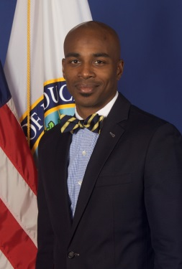
Dr. James T. Minor is the Deputy Assistant Secretary for Higher Education Programs in the Office of Postsecondary Education at the U.S. Department of Education. Dr. Minor most recently served as a Senior Program Officer and Director of Higher Education Programs for the Southern Education Foundation in Atlanta, Georgia. He has held other significant positions which include a tenured associate professor of higher education policy at Michigan State University, a fellow at the University of Georgia’s Institute for Higher Education, and Research Associate at the Pullias Center for Higher Education at the University of Southern California. An author of many scholarly articles, reviews, national reports, and book chapter, James holds a B.A. from Jackson State University, a M.A. from the University of Nebraska, and a Ph.D. from the University of Wisconsin-Madison.

Kelly Minton

Ted Mitchell

Ted Mitchell currently serves as the under secretary of education at the U.S. Department of Education. He has served in this post since his confirmation by the U.S. Senate, following his nomination by President Barack Obama. Dr. Mitchell oversees policies, programs, and activities related to postsecondary education, adult, career and technical education, federal student aid, five White House Initiatives and the Center for Faith-Based and Neighborhood Partnerships. To spur education, economic growth, and social prosperity, Mitchell is charged with planning and policy responsibilities to implement President Obama’s goal for the U.S. to have “the best educated, most competitive workforce in the world, as measured by the proportion of college graduates by the year 2020. Mitchell is the former CEO of the NewSchools Venture Fund and served as the president of the California State of Board Education. Through his long career in higher education, Mitchel has served as the president of Occidental College, vice chancellors and dean of the School of Education and Information Studies at the University of California, Los Angeles, and professor and chair of the Department of Education at Dartmouth College. Dr. Mitchell received his bachelor’s and master’s degrees, and Ph.D. from Stanford University.

Vela Mitchell

Vela McClam Mitchell is the Founder of Vimm Global, which is the holding company for the three businesses she owns and manages; Georgia International Travel, Lemae Group Wine Importers and Market Designs, LLC. Georgia International Travel, the primary business of the Vimm Global Company, is headquartered in Atlanta, Georgia and is a travel services representative for American Express. Vela acquired the multi-division travel management company in May 2006. The company’s primary focus is corporate travel management for over 150 corporations. It also provides its clients association, conference, meetings and vacation travel management.

Vela began her career on Capitol Hill as a legislative assistant to a United States Congressman from her home state of South Carolina. She graduated with a Bachelor of Science degree from Claflin University in 1975, a Master of Science from Howard University in 1977 and a MBA from Pepperdine University in 1986. She has also received certifications in Global Enterprise Management from the Kellogg College of Business at the University of Oxford in Oxford, England in 2002 and a Strategic Business Management from the Wharton School of Business at the University of Pennsylvania in 1988. Recently she added to her educational accomplishments by completing the Tuck (Dartmouth) School of Business/WBENC Executive Program for Women Business Owners and the Minority Business Development Program at the Kellogg Business School at Northwestern University.

Tameka Montgomery

Tameka Montgomery currently serves as the Associate Administrator of the Office of Entrepreneurial Development at the U.S. Small Business Administration. In that capacity, she manages the agency’s counseling and training programs which serve more than 1.5 million entrepreneurs and small businesses nationwide. Prior to joining SBA, Ms. Montgomery was the Executive Director of the Denver Metro Chamber Leadership Foundation, an affiliate of the Denver Metro Chamber of Commerce that is focused on preparing and connecting leaders from the business and civic communities to strengthen Colorado’s future. In 2011, Ms. Montgomery was named one of Denver Business Journal’s Forty under 40 and was recognized in 2012 as a Living Legend by the National Council of Negro Women. Ms. Montgomery is a graduate of Spelman College where she earned her bachelor’s degree and her master’s degree of public administration from Columbia University.

E. Elaine Moore

Loretta A. Moore

Charles Moses

Omar Muhammad

Charlie Nelms

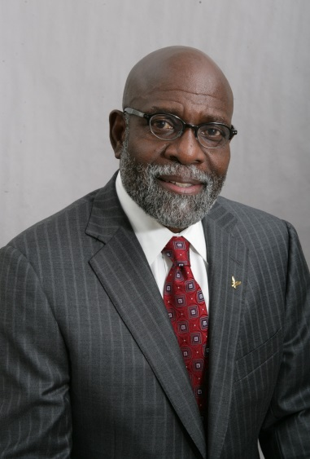
Dr. Charlie Nelms is currently a senior scholar at the American Association of State Colleges and Universities, specializing in providing assistance to minority-serving institutions. Dr. Nelms is also a founding member of the Millennium Leadership Initiative and vice president and professor emeritus at Indiana University. He also served as the tenth chancellor of North Carolina Central University. During his tenure at NCCU, Dr. Nelms is credited with guiding the establishment of the first and only Ph.D. program to be offered at the university in 50 years and creating the Division of Research and Economic Development which assisted the university in receiving the largest sponsored research grants in its history. Dr. Nelms earned a Bachelor of Science degree for the University of Arkansas at Pine Bluff and a master’s of education degree and Ed.D from Indiana University.

Dava Newman

Joseph Nsengimana
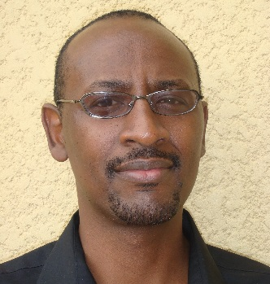
Joseph Nsengimana is the Senior Program Officer for University Initiatives at Intel Corporation. In this role, Joseph develops strategy and implements all University Initiatives funded through the $300m Diversity in Technology Fund that Intel established in January 2015, to reach full representation of women and underrepresented minorities at Intel by 2020 and to promote diversity in the technology and the gaming sectors. Prior to this role, Joseph was the Director of Programs and Strategic Alliances at the Intel Foundation. From 2008 to 2012, Joseph was based in Johannesburg, South Africa, where he held the role of Director of Corporate Affairs Group and Strategic Alliances in Africa for Intel Corporation. In this role, he led a team responsible for government affairs, ICT and broadband policies, and CSR in Sub Saharan Africa. Joseph served on the technical advisory committee of the African Leadership in ICT project to build capacity and raising awareness of African leaders on the issues of Knowledge Society, ICT, Education, Science & Technology and Innovations in support of EU-AU Strategic Partnership 8 and AUC action Plan; as well as on the ICT Taskforce of the Association for the development of education in Africa (ADEA). Joseph holds a BA and MS in Electrical Engineering from Brigham Young University

Mildred Huff Ofosu

Sharon Patterson

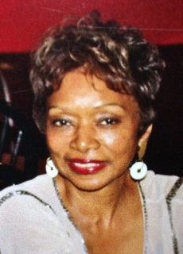
Sharon Patterson currently serves as President and Chief Executive Officer of Billion Dollar Roundtable (BDR). The Billion Dollar Roundtable promotes and shares best practices in supply chain diversity excellence through the production of white papers. Prior to her arrival at BDR, Ms. Patterson served as the Director of Kraft Foods. Additionally, Patterson is President of Amica Group Inc., a consulting company, and serves on the planning committee of the Tommie Agee Foundation and the Mobile Chamber Growth Alliance. Patterson received her MBA in finance and marketing from Northwestern University and her undergraduate degree in economics from Spelman College.

Maci Peterson
Maci Peterson, the CEO and co-founder of On Second Thought, is a DC-based entrepreneur with roots in Chicago. In 2015, she was named “Tech’s Newest Innovator” by Essence
Magazine and recognized among Washington Business Journal’s “40 Under 40”. On Second
Thought won First Place at SXSW's annual pitch competition #StartupOasis in 2014, was named "The Texting Savior" by AT&T, and was recently named a Top 10 finalist in the Women Who Tech Startup Challenge, in partnership with Craig Newmark of craigslist and Fred and Joanne Wilson. Before launching On Second Thought, Peterson was a brand manager at Marriott International and a marketing strategist for The Root. Peterson received her Bachelor of Arts in public relations and advertising from Chapman University.

Claudia Rankins
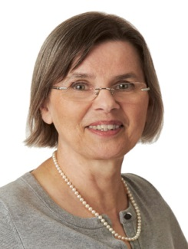
Claudia Rankins is a Program Officer in the Directorates for Education and Human Resources and for Mathematical and Physical Sciences at the National Science Foundation, where she manages the Historically Black Colleges and Universities Undergraduate Program and the Centers for Research Excellence in Science and Technology.

Prior to this post, Dr. Rankins served at Hampton University for 22 years in a number of capacities, including endowed university professor, chair of the department of physics, assistant dean for research, and dean of the School of Science.

Her formal education includes military training, certification as translator and interpreter for German, French and English, a B.S. in Mathematics from Christopher Newport University, an M.S. in Statistics from Old Dominion University, an M.S. in Physics, and a Ph.D. in Physics both from Hampton University.

Since 1998, Dr. Rankins secured over $10 million in external grants that supported pre-college activities as well as undergraduate education and research in science, technology, engineering and mathematics (STEM). Her research in theoretical particle physics focused on the development of a model to describe distribution amplitudes and form factors of pseudoscalar mesons. Dr. Rankins is the co-founder of the Society of STEM Women of Color, Inc.

Chera Reid

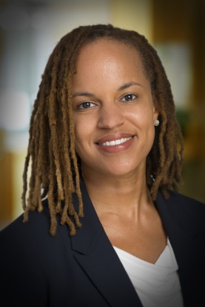
Chera D. Reid serves as a program officer for The Kresge Foundation’s Education Program, where her grantmaking activity promotes access and success in higher education for low-income, first-generation and underrepresented students.
Chera’s responsibilities include developing and refining grantmaking strategies, inviting and reviewing funding proposals, and monitoring existing grants. Her portfolio includes partnerships with minority-serving institutions on student success initiatives, with community colleges on issues of transfer and adult student degree completion, and with nonprofit organizations that leverage technology to foster college access and success.
“Improving college access and degree attainment benefits everyone, and I believe that we have to make that case to the public over and over again,” Chera says. “For low-income, first-generation and underrepresented students, the difference we can make is all the greater.”
Before joining Kresge in 2013, Chera worked in program development at MDRC, a national nonpartisan education and social policy research organization working to improve programs and policies that affect the poor. She previously held leadership positions at New York Needs You and the Phillips Academy Institute for Recruitment of Teachers, initiatives that expand educational and career opportunities for traditionally underserved populations. Chera has taught at colleges and universities including LaGuardia Community College in New York and New York University.
She earned a bachelor’s degree in English and African American Studies at the University of Virginia, a master’s degree at the University of Michigan and a doctorate from New York University, both in higher education. In 2011, she received the K. Patricia Cross Award for Future Leaders in Higher Education from the Association of American Colleges and Universities. She has published on higher education philanthropy at Historically Black Colleges and Universities and on college match for higher-achieving, low-income urban high school students.

Lee Rivers

Earl Robinson

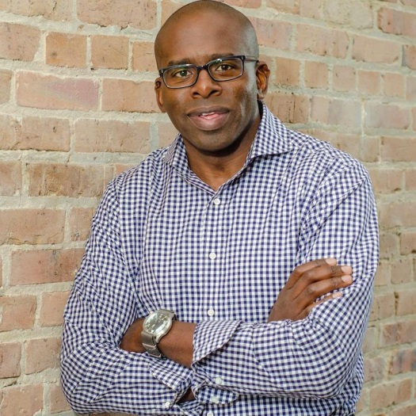
Earl Robinson is currently the President at PowerMoves.NOLA. He is a partner, founding principal, and an advisory board member of RLMcCall Capital. Mr. Robinson has worked in many realms of the private equity investment field as a Senior Vice President at Pacific Corporate Group, Operations Officer of JPMorgan Investment Management – Americas, and as Vice President at JPMorgan Investment Management, assisting the Chief Executive Officer with mergers, acquisitions, divestitures, product development, compensation matters and strategy. He began his career in corporate finance and mergers and acquisitions at Morgan Stanley & Co. Mr. Robinson received his BA in Economics from Wesleyan University and his MCA in Finance from Columbia Business School.

Elwood Robinson

Nancy Rodriguez
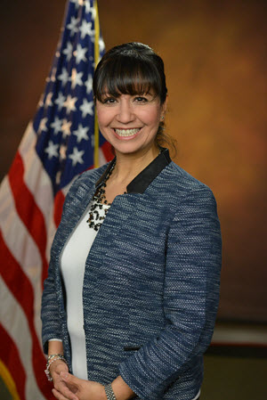
Nancy Rodriguez was sworn in as the director of the National Institute of Justice (NIJ) on February 9, 2015. Dr. Rodriguez's research expertise covers a wide range of criminal justice issues from the collateral consequences of imprisonment; the intersection of race, ethnicity, crime, and justice; to evaluations of drug courts and restorative justice programs. Her most recent work includes a longitudinal study of families affected by maternal and paternal incarceration.
From 1998–2012, Dr. Rodriguez was a professor in Arizona State University's (ASU) highly respected School of Criminology and Criminal Justice. She was named Associate Dean for Student Engagement in ASU's College of Public Programs in 2012.
A prolific writer, Dr. Rodriguez's work has appeared in numerous peer-reviewed journals, includingCriminology, Journal of Research in Crime and Delinquency, Criminal Justice and Behavior, Violence Against Women,Justice Quarterly, Crime & Delinquency, and Annals of the American Academy of Political and Social Science. She has co-authored two books: Just Cause or Just Because? Prosecution and Plea-bargaining Result in Prison Sentences of Low-level Drug Charges in California and Arizona and, most recently, Immigration Enforcement, Youth and Families: Policy in the Absence of Comprehensive Immigration Reform. She was co-editor of the 2006 book Images of Color, Images of Crime: Readings. Dr. Rodriguez's work has been recognized by some of the nation's top criminal justice professional organizations. In 2011, the Division on People of Color and Crime of the American Society of Criminology gave her the Coramae Richey Mann Award, and ASU's College of Public Programs gave her the Anne Larason Schneider Faculty Endowment for Community Research Award. She received the W.E.B. DuBois Award from the Western Society of Criminology in 2010. In 2009, she was named Alumni of the Year by the College of Criminal Justice at Sam Houston State University, and in 2015, she received the Outstanding Alumni Award from the Department of Criminal Justice and Criminology, Washington State University.
A native of El Paso, Texas, Dr. Rodriguez earned a Bachelor of Science in criminal justice from Sam Houston State University. She received her doctorate from Washington State University, in Pullman, Washington, where she concentrated in administration, justice, and applied-policy studies. She was appointed by President Barack Obama in October 2014 to head up NIJ, the scientific research arm of the U.S. Department of Justice.

Lamman Rucker

Lamman Rucker is an artist, educator, activist, and entrepreneur. Best known as the star of Tyler Perry’s “Why Did I Get Married” sequel films and hit film/sitcom “Meet the Browns”, Rucker is maintaining a powerful presence on large and small screens. Rucker may also be remembered on soap operas such as “As the World Turns” and “All My Children.” Rucker stars in several upcoming films including “Service to Man,” a period film about race relations in the South at Meharry Medical College. A passionate activist, Rucker is a spokesperson for several charitable efforts and community action initiatives including his non-profit The Black Gents, an all-male ensemble of actors driven to resurrect the positive images of Black males through thought-provoking high quality entertainment, youth empowerment initiatives and community service. A former high school educator, Rucker continues to use his teaching gift in several educational capacities such as arts and theater, health and wellness, and entrepreneurship and financial empowerment. He has contributed to several “edu-tainment” initiatives that empower and inspire while educating and has recently contributed an essay to a literary work entitled “REACH: 40 Black Men Speak on Living, Learning, and Succeeding” by Ben Jealous.

Stephanie Santoso

Megan Smith (Invited)

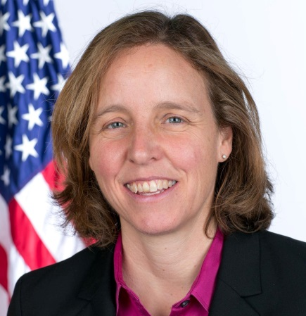
In September 2014, President Obama named Megan Smith the United States Chief Technology Officer (CTO) in the Office of Science and Technology Policy. In this role, she serves as an Assistant to the President. As U.S. CTO, Smith focuses on how technology policy, data and innovation can advance the future of our nation.
Megan Smith is an award-winning entrepreneur, engineer, and tech evangelist. She most recently served as a Vice President at Google, first leading New Business Development -- where she managed early-stage partnerships, pilot explorations, and technology licensing across Google’s global engineering and product teams for nine years -- and later serving as a VP in the leadership team at Google[x] -- where she co-created the company’s “SolveForX” innovation community project as well as its “WomenTechmakers” tech-diversity initiative and worked on a range of other projects. During her tenure she led the company’s acquisitions of major platforms such as Google Earth, Google Maps, and Picasa, and also served as GM of Google.org during its engineering transition, adding Google Crisis Response, Google for Nonprofits, and Earth Outreach/Engine, and increased employee engagement.
Megan previously served as CEO of PlanetOut, a leading LGBT online community in the early days of the web, where the team broke through many barriers and partnered closely with AOL, Yahoo!, MSN, and other major web players. Megan was part of designing early smartphone technologies at General Magic and worked on multimedia products at Apple Japan.
Over the years, Megan has contributed to a wide range of engineering projects, including an award-winning bicycle lock, space station construction program, and solar cookstoves. She was a member of the Massachusetts Institute of Technology (MIT) student team that designed, built, and raced a solar car 2000 miles across the Australian outback.
Megan has served on the boards of MIT, MIT Media Lab, MIT Technology Review, and Vital Voices; as a member of the USAID Advisory Committee on Voluntary Foreign Aid; and as an advisor to the Joan Ganz Cooney Center and the Malala Fund, which she co-founded. She holds a bachelor's and master's degrees in mechanical engineering from MIT, where she completed her master's thesis work at the MIT Media Lab.

Tiffany Smith-Anoa’i

Tiffany Smith-Anoa’i was named Senior Vice President, Diversity & Communications, CBS Entertainment in March 2015. In this position, she will expand upon the division’s current diversity initiatives, as well as develop new programs that recruit, nurture and hire diverse talent to work in front of and behind the camera. In addition, she will serve as the entertainment liaison to multi-cultural coalition groups and provide outreach to agencies, guilds and other industry organizations that represent diverse talent. Since being appointed Vice President, Entertainment Diversity & Communications, CBS Entertainment in 2009, Smith-Anoa'i has created and launched "CBS On Tour," a community outreach program in which executives visit schools to educate and encourage students interested in entertainment careers; expanded the writer selection process for "The CBS Diversity Sketch Comedy Showcase;" implemented an annual symposium with casting directors to strategize on best practices to diversify the casting process; partnered with GLAAD to host learning workshops and joined forces with the Geena Davis Institute on Gender in Media to encourage roles for women in front of and behind the camera. Prior to her work at CBS, Smith-Anoa’i was responsible for all aspects of publicity and promotions for Image Public Relations. Preceding her position at Image Public Relations, Smith-Anoa’i worked for NIKE, Inc. Smith-Anoa’i's community service and charity work includes the Make-A-Wish Foundation, Girl Up and Diamond in the Raw. Also, she maintains a close relationship with her alma mater, Howard University, where she graduated with honors from the School of Communications. In 2013, Howard University presented her with the “Global Visionary Award” for Outstanding Leadership in Diversity and Communications.

Lenny Springs

In November 2009, Mr. Springs was appointed as Senior Advisor for the Department of Education FSA, for Minority Serving and Under-Resourced Schools Division. Mr. Springs accountability includes working with the Department of Education, to provide support to Minority Serving Institutions, including Historically Black Colleges and Universities (HBCU’s), Hispanic Serving Institutions (HSI), Tribal Colleges and Universities (TCU) and Predominately Black Institutions (PBI). In addition, Mr. Springs works with all of the White House Initiatives for higher education for the development of strategies to enhance President Obama’s 2020 Post Secondary Education Goals. Mr. Springs presently serves on the Board of Directors for M&F Bank. He has formerly served: On the NAACP National Broad of Directors; NAACP Special Contribution Fund Board of Trustees. He is the founding President of the Greater Charlotte Chapter of the 100 Black Men of America Inc., and was past Chairman of Development for the National 100 Black Men of America, Inc. In addition, Mr. Springs has served on a number of Board of Trustees of Historically Black Colleges and Universities. He holds a BA in Business Administration and a Doctor of Humane Letters, Honoris Causa from Voorhees College.

Wayne Szanfranksi

﻿As the Assistant Vice Chancellor for Outreach and Economic Development, Mr. Wayne Szafranski is responsible for N.C. A&T’s intellectual property portfolio and technology transfer operations. He also is responsible for negotiating research relationships and contracts with commercial and federal agency partners. He represents the university in local, regional and state-wide economic development activities and on the boards of economic development organizations.
A native of Western New York, Wayne graduated from Clarkson University with bachelors and master’s degrees in chemistry and a certificate in photographic engineering. He has worked in technical product development and executive positions with several international companies, including Eastman Kodak, CIBA-Geigy Corporation, and Konica Manufacturing USA. He joined N.C. A&T in 2007.
Before joining N.C. A&T, he directed Technology Outreach at Nussbaum, a joint program of N.C. A&T, the University of North Carolina at Greensboro and the Nussbaum Center for Entrepreneurship that facilitated technology transfer, commercialization, and business development.

Asaad “Tibias” Thorne

Asaad Thorne is the owner of Urban Argyle, LLC, a company that uses clothing as an innovative means to create socially conscious statements. Asaad is a proud alumnus of North Carolina Agriculture & Technical State University.

Henry Tisdale

Ivory Toldson

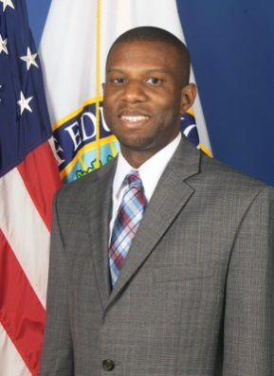
Dr. Ivory A. Toldson is currently the acting executive director the White House Initiative on Historically Black Colleges and Universities. While serving in this role, Dr. Toldson serves as an associate professor at Howard University. Prior to this, he served as a senior research analyst for the Congressional Black Caucus Foundation, and editor-in-chief of The Journal of Negro Education. Dr. Toldson has more than 60 publications, including 4 books, and more than 150 research presentations. He has been featured on MSNBC, C-SPAN2 Books, NPR News, POTUS on XM Satellite Radio, and numerous local radio shows. After completing coursework for a Ph.D. in Counseling Psychology at Temple University, Dr. Toldson became a correctional and forensic psychology resident at the United States Penitentiary. There, he completed his dissertation on Black Men in the Criminal Justice System. Upon Completion, Dr. Toldson became the fourth recipient of the DuBois Fellowship from the U.S. Department of Justice.

Scott Trapp

Scott Trapp is director of diversity outreach for Lockheed Martin Corporation. In this capacity, he is responsible for leading the Corporation’s corporate diversity and inclusion outreach strategies to grow relationships with strategic partners and help position Lockheed Martin as an employer of choice. His role incorporates Science, Technology, Engineering and Math (STEM) outreach and higher education initiatives as well as, talent sourcing and outreach and national diversity events. Prior to joining Lockheed Martin, Mr. Trapp served in a variety of increasingly responsible positions at Public Service Enterprise Group in Newark, NJ, most recently as the director of talent acquisition and diversity outreach. Mr. Trapp has more than 15 years of leadership experience with companies that include Exelon Energy Corporation, Association of Medical Colleges and the University of Maryland. Mr. Trapp graduated from California University of Pennsylvania with a Bachelor of Arts in Communications. He is a member of the Society of Human Resource Management, Alpha Phi Alpha Fraternity Inc. and is certified in Lominger Career Architect.

Francis Tuluri

Dr. Francis Tuluri is an Associate Professor in the Department of Technology at Jackson State University. He holds the following degrees: B.S. (Mathematics, Physics, and Chemistry), M.S. (Physics), and Ph.D. (Physics). Dr. Tuluri has longstanding teaching and research experience that spans more than two decades. He has taught a wide variety of courses, such as Analog and Digital Electronics, Semiconductor Physics and Devices, and Engineering Physics. He has developed teaching methods using technological teaching tools for pedagogy. Dr. Tuluri’s research interests include Solid State Electronics and Devices, Sensors and Electronics Instrumentation, Soft Materials Science and Computations, Biomedical Engineering, and Bio Imaging. He has published over 40 research papers in peer reviewed journals of national and international reputation.

Hannah Valentine

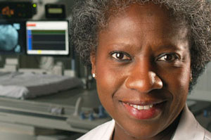
Hannah Valantine, M.D. was appointed to the position of Chief Officer for Scientific Workforce Diversity in January of 2014. Dr. Valantine leads the National institutes of Health’s (NIH) effort to diversify the biomedical research workforce by developing a vision and comprehensive strategy to expand recruitment and retention, and promote inclusiveness and equity throughout the biomedical research enterprise. Dr. Valantine is expected to begin her new role this spring.
Dr. Valantine comes to the NIH from Stanford University where she served as Senior Associate Dean for Diversity and Leadership at Stanford School of Medicine, and Professor of Cardiovascular Medicine at Stanford University Medical Center. Dr. Valantine studied biochemistry at London University and attended St. George’s Hospital Medical School. She completed her post-graduate work in the field of cardiology at two London hospitals, Brompton and Hammersmith. She moved to the United States to train as a fellow with leading cardiologists and cardiac surgeons, including heart transplant pioneer Norman Shumway, M.D., Ph.D. In addition to a prestigious career in cardiology, Dr. Valantine is a past recipient of the NIH Director’s Pathfinder Award for Diversity in the Scientific Workforce and has a proven record on implementing diversity initiatives in academic medicine.

Michael P. Verchot

Michael Verchot is the founding director of the University of Washington’s Consulting and Business Development Center (formerly known as the Business & Economic Development Center or BEDC) and a Lecturer in the Marketing and International Business Department at the Michael G. Foster School of Business. Michael expanded the center’s work from a regional to a national focus in 2009 by launching the Minority Business Executive Program. The center is building a 100-member nation-wide association of business schools that engage faculty and students with MWBEs and other businesses in underserved communities. Michael is co-author, with William Bradford, of “The Washington Minority Small Business Survey,” “The State of Minority-Owned Businesses in Washington” and “The Impact of African Americans on the Economy of Washington State.” He is also the co-author, with Mina Yoo of “Minority and Women-Owned Businesses in Washington’s Green Economy” (2008). Michael serves on the Washington State Community Advisory Board for JPMorgan Chase. He received his MBA from the University of Washington in 1995 and his undergraduate degree from Springfield College (MA) in 1981.

Beverly Wade-Hogan
Beverly Wade Hogan has served as President at Tougaloo College since May 2002. She is the first woman and the 13th president to lead this historic institution.
Hogan is often described as a visionary, an innovative and strategic thinker, and disciplined, compassionate, firm, fair, analytical and spiritual leader. Under her leadership, new undergraduate degree programs in mass communications, hotel and hospitality management and religious studies as well as two graduate degree programs have been added. A new Honors Program and three centers have been established—the Center for Undergraduate Research, the Center for Continuing/Online Education, and the Center for International Studies and Global Change. The College was designated as a Center of Excellence in Transportation Security by the U. S. Department of Homeland Security and selected as one of seven institutions to participate in the Campus Resilience Project. Significant technological improvements have been made, including campus wide connectivity, smart classrooms and wireless networks and the construction of the Bennie G. Thompson Academic and Civil Rights Research Center.
Prior to becoming President, Hogan served as the College’s Interim President, Vice President for Institutional Advancement and founding director of the Owens Health and Wellness Center. An effective and committed leader, she served as the Commissioner for the Mississippi Workers’ Compensation Commission, the Executive Director of the Governor’s Office of Federal State Programs and the Executive Director of the Mental Health Association in Hinds County and the state of Mississippi, respectively. She has been an adjunct instructor in leadership and public policy at Jackson State University and a frequent guest lecturer at the University of Mississippi and Mississippi State University. Additionally she has been involved with employment and educational training programs in Denmark, Sweden and West Germany in affiliation with the German Marshall Fund. She has been a scholar with the Kettering Foundation where her research focus was Higher Education and Civic Responsibility, a participant and presenter in the Oxford Roundtable at Oxford University in Oxford, England and a participant in leadership seminars at Harvard University.
Hogan earned her Bachelor of Arts degree in psychology from Tougaloo College and masters in public policy and administration from Jackson State University. She has done additional studies in clinical psychology at the University of Southern Mississippi and University of Georgia. She engaged in further doctoral studies in human and organizational development at Fielding Graduate University. She holds Honorary Doctorates from Wiley, Rust and Benedict Colleges and Brown University, and has earned numerous professional certificates in leadership development, organizational management and administrative law.
Hogan has received extensive recognition for her trailblazing contributions. Among her extensive roster of achievements, she is the founder of the first psychiatric halfway house in the state of Mississippi. She has authored and published works on topics such as “The Dissonance Analysis of the Viet Nam War,” “Comparable Worth—the Challenging Issue of Pay Equity,” Jobs and Economic Growth,” “Public Policy Implications of AIDS in the Workplace,” “Higher Education and Civic Responsibility” and “Gender and Race” as a chapter in a textbook, Leadership and Service, published in 2008.
Active in an array of professional and civic organizations, Hogan serves on various boards, including Bancorp South, Sanderson Farms, the Jackson Medical Mall Foundation and RAND’s Gulf States Policy Institute. She is also a member of the national board of directors for the United Negro College Fund. Hogan was appointed by President Barack Obama to serve on the President’s Board of Advisors on HBCUs. She is also a founding member and former president of the Central Mississippi Chapter, National Coalition of 100 Black Women, and a member of Alpha Kappa Alpha Sorority and the Links, Inc.
She and her husband Marvin have two adult sons and six grandchildren.

Michael Wallace

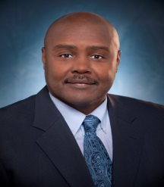
Michael Wallace brings the strategic focus, vision and mature judgment at Walmart, a Fortune One company. He has worked at Walmart Inc. for the last seven years is currently the Director of Global Diversity & Inclusion.
Throughout Michael’s 25 plus year career he has embraced core values of Integrity, inclusion and striving for excellence. He has worked in multiple industries and built a reputation for developing business strategies, incubating new cost saving business models, and his ability to innovate. Michael utilizes his entrepreneurial experience gained while working in Silicon Valley, the dynamic combinations of Inclusion, diversity of thought, and his consulting experience to exceed expectations. Michael was selected to speak on Inclusive Leadership and Unconscious Bias at the 2015 USDA Agricultural Outlook Forum as a representative of both Walmart and the Cotton Board. He has served as a Board Member on the Cotton Board for the last four years and serves as the Vice Chair of the Global Supply Chain Marketing Committee and is also a member of Retail Industry Leaders Association (RILA).

Don Watson

Charles A. Weatherford

David Weaver

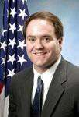
David Weaver is the Associate Commissioner for Research, Demonstration, and Employment Support at the Social Security Administration. He oversees key agency initiatives including efforts to replace the aging Dictionary of Occupational Titles (used for disability determinations), to maintain and further develop the Quick Disability Determination process, to conduct research on issues affecting the nation’s disability programs, and to administer the agency’s employment support programs. From 2004 through 2011, David was the Deputy Associate Commissioner for Retirement Policy. In that capacity, he oversaw the agency’s efforts to use microsimulation models to analyze, for Congress and the White House, the effects of Social Security options and proposals on the American public. David began his service with the agency in 1992. Prior to moving to management in 2004, David worked as a research economist in the Office of Research, Evaluation, and Statistics. He has authored several articles in both peer-reviewed professional journals and in agency publications on the economic well-being of the Social Security beneficiary population and the effects of alternative policy proposals on the beneficiary population. David holds a Bachelor's degree in Economics and History from Furman University and a Ph.D. in Economics from Duke University.

Joseph Wells

Katherine Wheatle

Mary N. Whigham-Jones

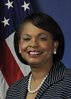
Deputy Director, Ms. Jones provides senior civil rights leadership and support for all Department of Transportation (DOT) programs and activities. She provides civil rights policy guidance and oversight to the DOT operating administrations and secretarial offices on civil rights programs.
Previously, Ms. Jones served as the Deputy Assistant Administrator for Civil Rights at the Federal Aviation Administration’s (FAA) Office of Civil Rights. There she provided senior leadership, policy direction, and technical assistance for internal and external civil rights programs, including FAA’s signature initiative to create and maintain a model work environment.
Ms. Jones began her Federal career with the FAA’s Office of Chief Counsel where she served in several capacities. As an attorney advisor in the Enforcement & Regulations Division, she had responsibility for rulemaking projects and handled aviation safety related enforcement actions against airmen and aviation entities before the National Transportation Safety Board. Further, Ms. Jones served as legal advisor/trial attorney, and later manager, in the Personnel & Labor Law Branch where she was responsible for employment litigation matters before the Equal Employment Opportunity Commission, the Merit System Protection Board, the various Federal district courts, as well as appellate matters before the U. S. Court of Appeals for the Federal Circuit. Ms. Jones regularly served as the Acting Assistant Chief Counsel, General Legal Services Division where her responsibilities included employment law, government ethics, FOIA, and Privacy Act matters.
Ms. Jones, a 2010 recipient of the Meritorious Executive Presidential Rank Award, received her Juris Doctor degree from Temple University School of Law and Bachelor of Science degree in Political Science from Tuskegee Institute (now University). Further, she completed Executive Programs at the Kellogg School of Management, Northwestern University. Ms. Jones is a member of the Pennsylvania and District of Columbia bars.

Leon White

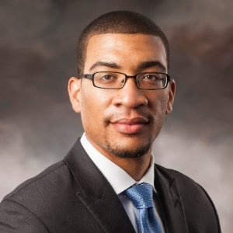
Leon White graduated from Charles Herbert Flowers High School in Maryland with high honors. He went on to pursue his degree in mechanical engineering at North Carolina A&T State University and graduated summa cum laude in the top 2% of his class. He is currently pursuing his PhD in mechanical engineering with concentrations in biodegradable magnesium alloys. It is his hopes that through his research that he will be able to give major contributions to the biomedical field with human implants. He lives by Mahatma Gandhi’s philosophy “Live as if you were to die tomorrow. Learn as if you were to live forever.”

Harry Williams

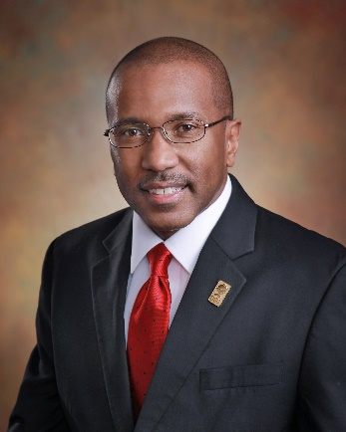
Dr. Harry Williams serves as the 10th President of Delaware State University, after serving as the institution’s Provost and Vice President for Academic Affairs. Shortly after beginning his tenure as president, Dr. Williams convened a Blue Ribbon Commission that crafted a new vision statement and a set of core values to establish Delaware State as one of America’s most highly respected HBCUs. Prior to his arrival at DSU, Dr. Williams served as the interim associate vice president for academic affairs at the University of North Carolina. In addition to his experience within institutions of higher education, Dr. Williams was a national marketing and recruitment associate consultant with Noel-Levitz, the top national consultation firm for enrollment and management solutions in the country. In that capacity, Dr. Williams provided consultation expertise to 14 different institutions of higher education, including Delaware State University.

Kezia Williams

David Wilson

Angela Woods

Chad Womack

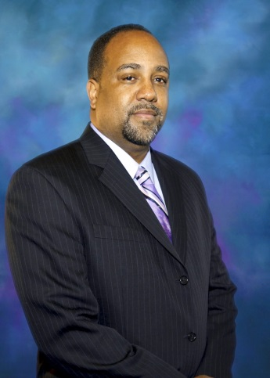
Dr. Chad Womack is a science educator and technology entrepreneur, researcher, and scholar. Dr. Womack currently serves as the National Director of STEM Education Initiatives and the UNCF Merck Fellowship Program at the United Negro College Fund. In his current capacity at the UNCF, Dr. Womack leads the organization’s strategic direction to address unmet educational needs in STEM college and career pipeline for African American students. In addition, Dr. Womack is a Co-Founder and Principal of The America21 Project, an innovation-based community organization dedicated to empower urban centers and underserved communities through science, technology and innovation. Dr. Womack earned his Ph.D. in Biomedical Sciences from the Morehouse School of Medicine, and is a graduate of Morehouse College.

Joseph Wyatt

Dorothy Cowser Yancy

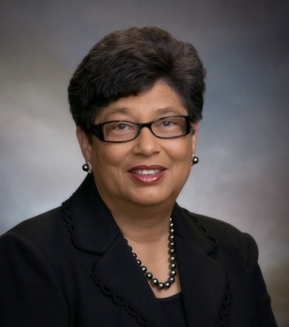
By promoting civil integration and exhibiting keen leadership, Dr. Dorothy Yancy has modeled a life of distinction by shaping the way African-Americans excel in higher academia.
Yancy majored in social science and history, eventually entering the doctoral program in political science at Atlanta University, where she became an accomplished scholar.
Her professional career became one of inaugural feats.
After post-graduate positions at institutions such as the University of Singapore, Hampton University, Northeastern Illinois University and Northwestern University, Yancy settled at the Georgia Institute of Technology. In 1972, she became the first African-American at Georgia Tech to be promoted and tenured as a full professor in history, technology, and society and management.
Yancy remained at Georgia Tech until 1994, when she became the first female president of Johnson C. Smith University.
At Johnson C. Smith, Yancy garnered a reputation as a financial champion for historically Black colleges. Between 1994 and 2008, she completed two significant capital campaigns at the university. For the “Vision Shared: Campaign for the 90s,” Yancy exceeded her fundraising goal by $13.8 million. For “Pathways to Success,” she again exceeded the financial goal, with an excess of $6.5 million. Since 1994, Yancy raised more than $145 million for the university.
In 2009, Shaw University called on Yancy to provide stability during a management crisis and rapid leadership turnover, making her the first female interim president at the institution. At the time, Shaw was listed in Bank of America’s Toxic Asset group, with a composite financial index (CFI) score of -.36. In just 15 months, Yancy stabilized the university by securing a $31 million federal loan, bringing its CFI score to a positive 2.6.
Under Yancy’s leadership, Shaw also saw landmark increases in enrollment, received its accreditation from the Southern Association of Colleges and Schools (SACS) and program reaffirmations. She returned in 2011 as president to assist the university in recovering from a tornado that caused nearly $4 million in damage.
After serving a second stint at Shaw University, Yancy retired in late 2013.

Geoffrey H. Young

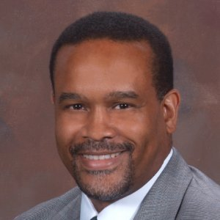
Geoffrey Young, Ph.D. earned his B.A. from Hampton University and his M.A. and Ph.D. in clinical psychology from the Ohio State University. He began his clinical career in 1990 at the University of Medicine and Dentistry of New Jersey- University Behavioral Healthcare treating adults and children living in underserved communities. He joined the faculty at the University of Medicine and Dentistry of New Jersey- Robert Wood Johnson (RWJ) Medical School in 1995 and was appointed Assistant Dean for Multicultural and Student Affairs in 1996. He created an office of multicultural affairs and worked extensively with faculty and students to address issues of diversity and student support. Dr. Young has served as the Associate Dean for Students Affairs at Virginia Commonwealth University, Medical College of Virginia Campus between 2004 and 2007. He was hired at the Medical College of Georgia School of Medicine as the Associate Dean for Admissions. His primary administrative responsibility is the management of the admissions office and of the admissions process for the School of Medicine. Dr. Young is an Associate Professor in the Department of Psychiatry and Health Behavior. His clinical interests include working with adults from underserved communities.

