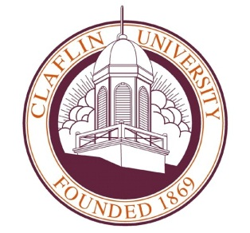
Claflin University
Office of Communications & Marketing

For Immediate Release
April 21, 2014

Contact
Charlene D. Slaughter ~ 803-535-5077 (office) ~ 803-308-1807 (cell) ~ cslaughter@claflin.edu
Wendy Jeffcoat Crider ~ 803-535-5751 (office) ~ wjeffcoatcrider@claflin.edu
________________________________________________________________________________
Claflin University achieves record 52.2 percent alumni giving rate

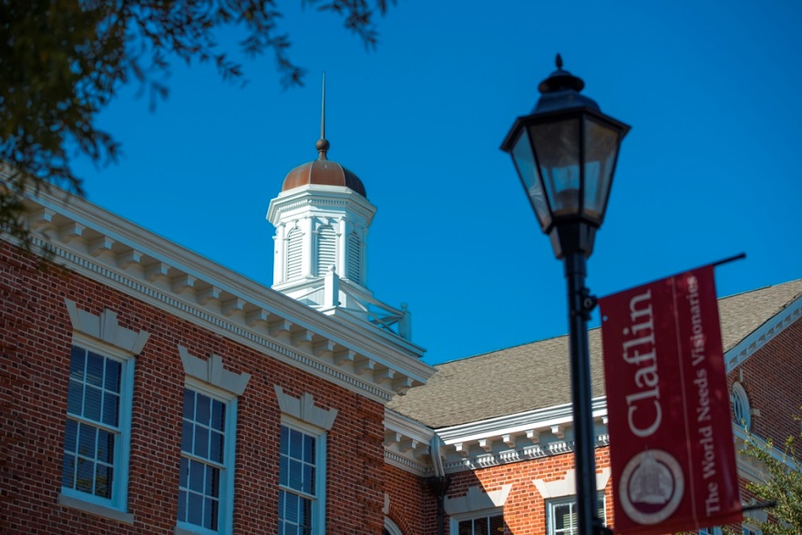
Claflin University alumni giving percentage increased nearly 10 percentage points in 2013, from 43 percent to 52.2 percent. The percentage places Claflin’s alumni giving rate among the best in the nation.
“We have always been proud of the support we receive from our alumni,” said Rev. Whittaker V. Middleton, vice president for Institutional Advancement at Claflin. “A few years ago, we started the 1st to 50 Campaign to become the first historically black college or university to reach a 50 percent alumni giving rate. We have received an overwhelming response, and can now say we are the First to 52.2.”
The journey to 52.2 percent was a strategic one, Middleton said, that involved strengthening existing initiatives, embarking on new ones, embracing new technology, collaborating with the alumni association, involving communications and marketing staff, and solid leadership.
Achieving an alumni giving percentage rate over 50 percent is a difficult feat given the culture of alumni giving at colleges and universities nationwide. In a 2013 two-year comparative survey of the top 10 colleges where alumni give back conducted by U.S. News and World Report, giving percentages range from a high of 63.7 percent to 51.8 percent. Of the top 10, nine were liberal arts colleges. The average two-year average percentage of alumni donors for the 1,207 schools surveyed was 12.8. The average for the top 10 schools was 55.9 percent.
“The high proportion of graduates who give back at these schools comes at a time when the broader percentage of alumni donors and the amount they give have declined, according to a 2012 survey by the Council for Aid to Education,” the report stated.
Claflin used several strategies to achieve its 52.2 percent giving rate. Allen Jackson, director of Alumni Affairs and the Annual Fund, said there has been a deliberate effort to engage affinity groups – campus groups linked by a common interest or purpose – and encourage them to give back to the University.
“We have found that individuals are more likely to give back when they feel a connection or affinity to institution,” Jackson said. “This can be in the form of Greek organizations or perhaps a certain major or members of athletics teams. The goal is to make that connection, giving donors the opportunity to give back to the areas that mean the most to them.”
Considerable attention is devoted to raising funds and promoting giving among the University’s classes meeting in reunions. While activities are planned for all classes in multiples of five, special attention is given to the 50th anniversary reunion class each year in an effort to increase the number of planned gifts received from this particular segment of the alumni constituency. This engagement has led to an increase in the percentage of giving from class reunions.
The University also gave donors more ways to give in order to remain competitive in today’s fundraising arena. Online giving became an essential component of the fund development program. Since launching online giving in 2008, the advancement office has experienced a steady increase in online gifts, representing a growth of 301 percent. Mobile giving was launched in 2011, allowing donors the option to text to give to the University, and Claflin also launched a wireless credit card processing program giving donors the convenience of making a gift via credit or debit card.
Another key strategy was the addition of the Claflin University Call Center which was birthed out of a very successful initiative the advancement office used for many years prior – the Claflin University Phone-a-Thon. Each year, staff and volunteers would call alumni and friends to solicit donations to the University. In 2010, the Claflin University Call Center was launched to use calling as a solicitation tool on a more consistent and strategic basis.
“In today’s world, we have so many methods of communicating, but a phone call still garners results when it comes to fundraising,” said Marilyn Keenan, manager of the Call Center. “We employ our students, which gives each call an even more personal and meaningful touch.”
The ability to effectively market fundraising goals has also greatly benefitted alumni giving at Claflin. Advancement officers work closely with communications and marketing staff to strategically plan marketing efforts – from direct mail to social media and email appeals.
Claflin now communicates more frequently with its stakeholders through tools such as email blasts, text messages, the University magazine, special newsletters, Facebook, Twitter, YouTube, automated voice messages, and custom brochures and publications.
Middleton said University leadership and the campus community are heavily engaged in the fundraising process and support fundraising initiatives. From the Board of Trustees and president, to the student body, faculty and staff, a culture of giving has emerged and is continuing to grow.
“As leaders, we have to set an example,” President Dr. Henry N. Tisdale said. “As an advancement team and the University overall, we have to be willing to invest in Claflin if we are going to ask others to do so. I am proud to say that in our current capital campaign, 98 percent of our administration, faculty and staff have given back to the University. Even more impressive is the fact that our students surpassed a $100,000 goal, and are currently in the midst of a second campaign.”
“Our alumni are no different,” Tisdale continued. “We are proactive in presenting new fundraising strategies, but their commitment and loyalty to their alma mater is why we have reached 52.2 percent. We certainly want others to invest in us. But more importantly, we invest in ourselves.”

