s.j. davis middle school

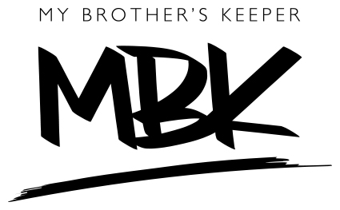

my brother’s keeper

mentor application & questionnaire

4702 E. Houston St. • San Antonio, TX 78220
Phone: 210-978-7920 Fax: 210-662-8189

s.j. davis middle school

MBK questionnaire

Name: ________________________________________________________________

Why do you think it is important to be a mentor/mentee in the MBK Program?
_______________________________________________________________________

What do you hope to gain from the MBK relationship? __________________________

_______________________________________________________________________

List your hobbies: ________________________________________________________

What are three (3) words that best describe you? ______________________________

What sports do you like? __________________________________________________

What is your favorite color? _______________________________________________

List some things or actions you dislike: _______________________________________

_______________________________________________________________________

What else would you like your mentor/mentee to know about you? _________________

_______________________________________________________________________

_______________________________________________________________________

s.j. davis middle school

MENTOR application

Name: ________________________________________________________________

Phone: __________________________ Email: _____________________________

Address: _______________________________________________________________

City: ____________________________ State: ________ Zip: ______________

DOB (MM/DD only): _______________ Occupation: ________________________

Professional training, skills, etc.: ____________________________________________

_______________________________________________________________________

Community Affiliations (clubs, service organization, etc.): ________________________

_______________________________________________________________________

Hobbies: _______________________________________________________________

Why do you think it is important to be a mentor in the MBK Program? ______________

_______________________________________________________________________

What goals do you want to achieve as a mentor in the MBK program?________________

_______________________________________________________________________

Below are the MBK Goals. Please rank them in order of importance to you:

____ ensure all youth attend school daily

____ ensure all youth graduate from high school

____ ensure all youth complete post-secondary education or training

____ ensure all youth out of school are employed

____ ensure all youth are safe from violent crime
____ ensure all youth who have been convicted or incarcerated receive
opportunity to lead a productive life

____ ensure that local efforts are sustainable

There are three (3) main field trips that mentors will attend with their mentees. Please check the ones you will attend.

____ Sam Houston HS football game

____ College visit

____ Restaurant etiquette

Schedule of Availability (check all days/times you are available)

DAY | MORNING | AFTERNOON
Monday | ________ | ________
Tuesday | ________ | ________
Wednesday | ________ | ________
Thursday | ________ | ________
Friday | ________ | ________

